NOAA Coral Reef Conservation Program
Final Report Template

- Project Information
- NOAA Grant Number: NA11NOS4820006
- Project Title: Wahikuli-Honokōwai Agricultural Road Drainage Improvement Project
- PI and Staff: Wes Nohara, West Maui Soil and Water Conservation District
- Award Period:Nov.15, 2013 – Sept.30, 2014
- Award Amount: $30,009.00

- Executive Summary
This pilot project worked on two stretches of agricultural roads in Wahikuli and Honokōwai watersheds that were identified as problem areas for sediment erosion leading to stress on coastal ecosystems. Working with landowners and an engineer, specifications were created for where the construction contractors should put water bars, and reestablish/modify terraces. Improvements were made to 3.2 miles of road (see map, Appendix 2), which slightly exceeded the specified dimensions, and have for our purposes resulted in more functional water diversion systems that will slow and divert run-off and sediment accumulated in rain fall events, preventing it from continuing into the gulches and down to coastal waters where it stresses reefs. The capacity of two local contractors has been increased, and this pilot scale project has facilitated an understanding of the steps that will be required for the larger-scale Phase II project to follow this fall.

- Purpose
  - Management problem addressed: Ag roads and drainage systems (terraces & water bars) have deteriorated since the closure of most farming activities on the agricultural lands in the Honokōwai and Wahikuli watersheds. As a result, there is a significant amount of soil erosion, particularly on the steepest roads running parallel to the grade. This sediment is transported into the gulches, some percentage of which makes its way into the ocean during rain events. This project was able to address sediment transport in two stretches of road.

B. Overarching goal(s) and objective(s) of the project:
Goal: To improve coastal water quality and coral ecosystem function and health by reducing land-based pollution.
Objective: Reduce pollutant load to surface water and groundwater through site-specific actions and best management practices on two sections of eroding agricultural roads. Specifically;
- Solidify the relationships and build local equipment operator capacity in maintaining agricultural dirt road BMPs.
- Reduce the amount of sediment generated off two earthen access road surfaces and associated terraces.
- Reduce sediment loads carried by the road network to the near-shore ocean waters.

- Approach
A. Detailed description of the work that was performed (by objective)
The following steps were taken in carrying out this project.
- Land owner coordination: agreement from landowners to participate, provide 50% matching funds and sign off on the maintenance terms was secured in advance of the project, and followed throughout the project. This included securing access and ensuring the insurance terms were satisfied by contractors.
- Securing contractors: three contractors were needed to carry out the work. The first was an engineer who has experience with earthen road BMPs for sediment reduction. The other two were needed to carry out the road construction work. To this end, scope of work documents were prepared, contractor meetings held, board approval sought and contractors selected. For an example of construction contractor scope of work, please see Appendix 3.
- Engineering assessment: the contracted engineer conducted site visits to the two road areas, and mapped out the frequency and type of BMP to be used. Meetings with the construction contractors were held to ensure understanding of the specifications.
- BMP Construction: on each of the two properties, heavy equipment was used to grade the roads, create water bars and open terraces as per NRCS specs and the engineer’s design.
- Oversight and inspection: at intervals during the construction, WMSWCD provided oversight and checked in with construction contractors to make sure that the work was being carried out correctly.

B. Project management: List of individuals and/or organizations performing the work.
Wes Nohara, WMSWCD Board member: project oversight including supervision of construction, oversight of contracts, communication with board and partners
Tova Callender, West Maui Watershed Coordinator: project coordination including administration, communication between partners, reporting, budgets, landowner permission and match securing
Maggie Kramp, SWCD: coordination with board, administration of billing, reports etc.
Andy Hood, SRGII Inc.: contracted engineer for road specifications
David Minami, West Maui Land Co.: contractor for construction of BMPs on DHHL land
Robert Rita, Rita: contractor for construction of BMPs on General Finance Land
John Tomoso, Tri-Isle RC&D: fiscal agent for paying contractors

- Results
Improvements were made on DHHL land along Puka Camp Rd and on General Finance Group (GFG) Land on the diagonal road.
On Puka Camp Rd., 1.7 miles of road was improved and ~6000 linear feet of terraces were opened. The terraces were modified from a traditional pineapple plantation design to a reef friendly design by preventing hydrologic connectivity to the gulches. This was done by limiting how far the terraces cross the field, designing them to end ~300 feet into the field where water and mobilized sediment can be dissipated into the field.
On the diagonal GFG road, 1.5 miles of road was improved by grading, and through the addition of waterbars at specified intervals to allow the energy of the water to dissipate into the fields at intervals, rather than allowing speed and sediment to build over large runs that eventually connect to the gulch. Please see Appendix 1 for a photo of an example waterbar on this road.

- Applications
Outputs and management outcomes achieved. Outputs are defined as products/deliverables (e.g. reports, publications, databases, models, workshops). Outcomes are defined as changes in user knowledge or action. How did your project benefit resource managers? How has your project led to societal improvements, if any? What partnerships were established with other federal, state, or local agencies, or other research institutions (other than those already described in the original proposal)?
This project treated three out of 32 total miles of eroding earthen roads in these two watersheds. While the road work reduces threats to the coastal environment, the management outcomes of this project exceed simply the length of road and terraces improved. The next phase of this project which is funded by EPA/DOH, will allow for much greater scale of road improvement. By engaging the partners we did in this phase, we have piloted the process, and tested out working with various contractors. We now know what is needed to secure access to these lands, and have worked with the respective points of contact. SRGII who worked as the engineer on this phase, holds the contract for the next phase, so is in a position to directly apply what they have learned going forward.
In addition, the construction contractors we worked with also manage other lands in West Maui. Through this process, they have been trained in how to create and maintain earthen road BMPs and have a higher likelihood that they will do so on their own in the future.

- Evaluation
Describe the extent to which the project goals and objectives were attained. Provide explanation for modification of goals and objectives or problems that developed which resulted in less than satisfactory or negative results. Describe need, if any, for additional work.

The goals and objectives of this project as specified in the proposal were fully met. The mileage of road improved was slightly more than specified due to the willingness of the contractors to work additional hours to maximize the improvements that could be made.

Final Report Prepared by: ___Tova Callender_______________ Date submitted: _________________

Signature of Point of Contact: ______________________________

Appendix 1
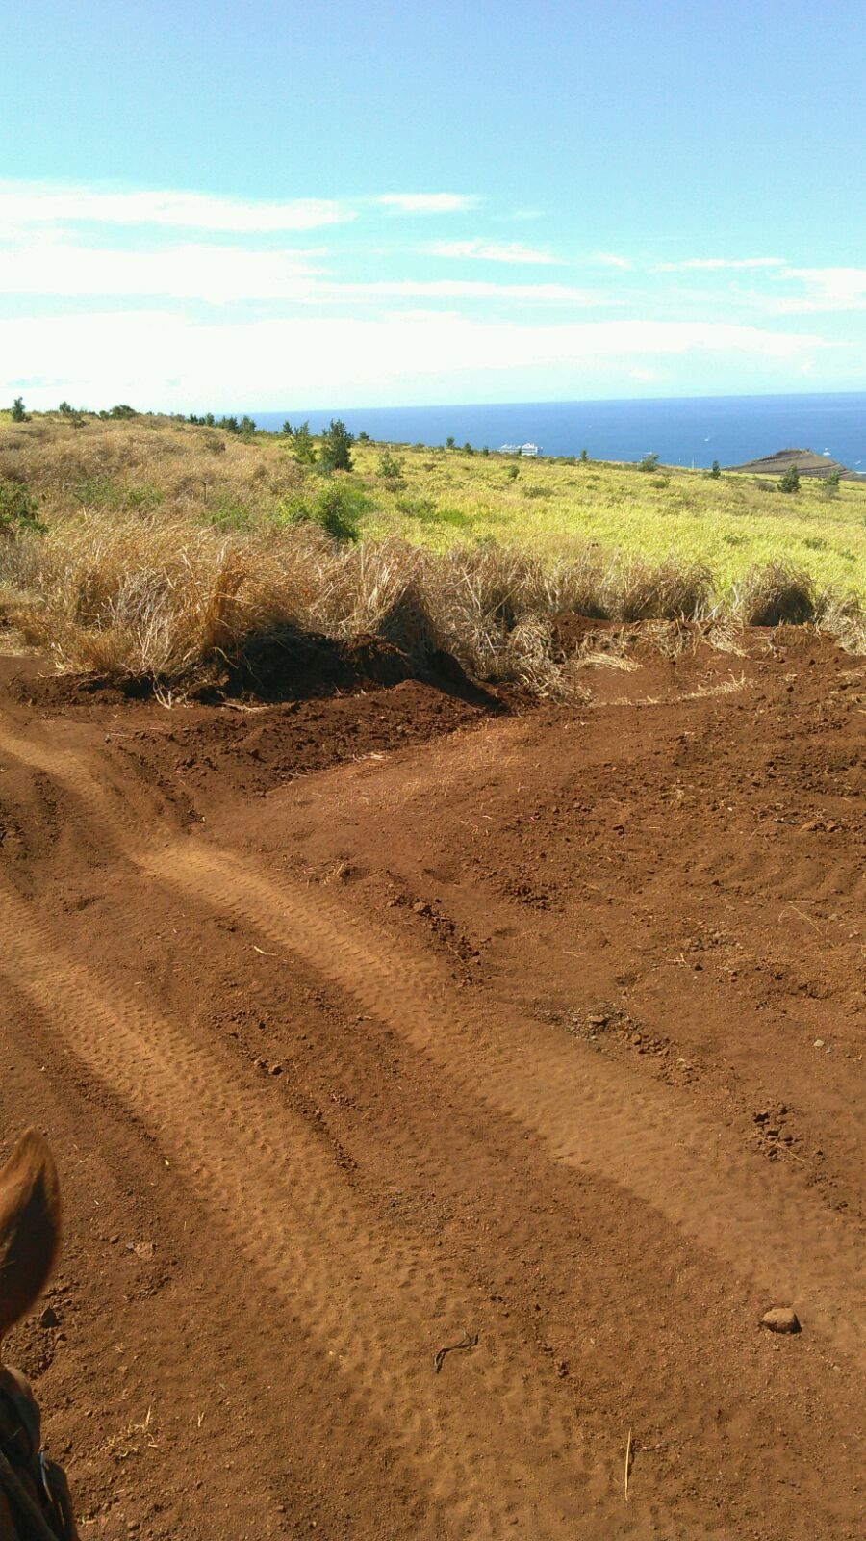
Figure 1: Waterbar and opening of terrace on General Finance Group Road

Appendix 2:
Figure 2: Agricultural Roads Included in sedimentation reduction project
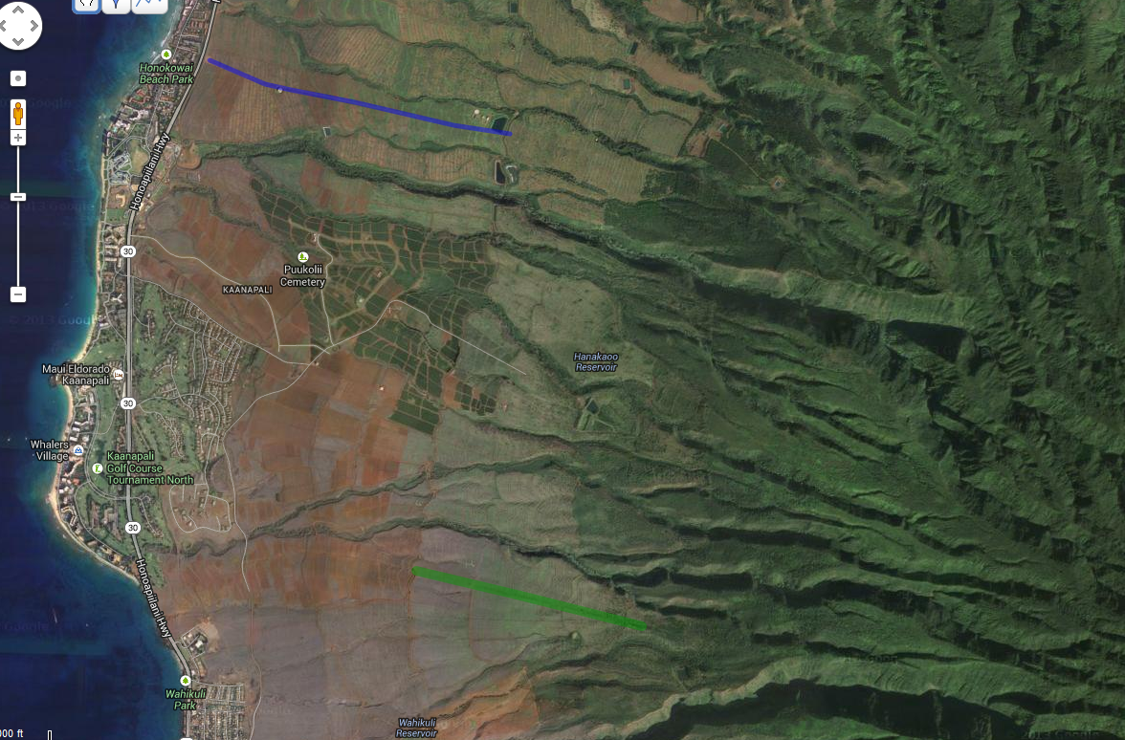

Notes: DHHL road delineated in blue, GFG road in green.

Appendix 3: Example Scope of Work for Construction Contractor
Scope of Work for Construction Contractor- Department of Hawaiian Homelands

Background:
The West Maui Soil and Water Conservation District has contracted Sustainable Resources Group Intn’l, Inc. (SRGII) as the Projected Engineer for this work. SRGII has prepared the following scope of work (SOW) as part of the Agricultural Road Improvements in West Maui Wahikuli-Honokowai Watersheds- Phase 1, a Wahikuli-Honokōwai Watershed Management Plan Implementation Project sponsored by the West Maui Ridge to Reef Initiative.
SRGII is working in cooperation with the West Maui Soil and Water Conservation District (WMSWCD) and the West Maui Watershed Coordinator (who will coordinate land access and other logistics) on improvements to select earthen agricultural roads in West Maui. Natural Resources Conservation Service (NRCS) specs and technical information were utilized in the design of BMPs. The following scope of work is to accompany the constructor services agreement.
_____________________________________________________________________________________
Task 1: Site Locations of BMP Installations for Roads on DHHL Land
- Contractor will meet with the Project Engineer (PE) at the project work sites (roads) after location for installation of broad based dips and other drainage features have been identified in the field and staked out. Each installation location will be visited and Contractor and PE will review specifications.
  - Contractor will be provided a map with each installation location delineated using unique site code.
  - Contractor will be provided specifications for broad based dips and other drainage features installation.
Task 2: BMP Construction
- Contractor will install broad based dips, kick out ditches, and micro detention basins or spreader fans as specified in site plans. All installation work shall be completed by September 20, 2014.
Task 3: BMP Close Out Inspection
- Contractor will meet with PE and review installations to verify completion and compliance with installation specifications. Inspection will occur within seven days of Contractor completing installation.

Site Specifications- Department of Hawaiian Homelands
- Work will occur over 11,250 feet linear feet of road.
- Installation of approximately 68 broad based dips fitted with kick ditches terminating into spreader fans or micro detention basins.
General Specifications
- Road surface will be graded to remove ruts, rills, and ridges to create a plane surface. Road surface will be graded to create inslope, outslope, or crown center slope as determined by PE and markup in field. Slopes will, to the extent possible, align with existing pitches and cross slopes.
- Broad Based Dip Construction Notes
- Excavate at a 30- to 45-degree angle to the road.
- Allow at least 150 feet for the entire dip.
- Build the top of the berm at least 18 inches higher than the bottom of the dip.
- Minimum depth of dip below upstream grade 12 inches.
- Dig the dip outlet lower than the upper end to set a slope of 3% or greater. Water will flow across it and out into the adjoining vegetated area instead of pooling in the bottom of the dip.
- Compact to 90 percent fill to create an 18 inch berm and finish to a uniform finish. Approach angles to be determined.
- Slope kick out ditch to a minimum of 3% to insure drainage.
- Prevent topographic breaks between contact of broad based dip outlet and inlet of kick out ditch.
- Remove all loose fill and other detritus from road surface upon completion of dip installation.
- Cut and fill quantities unknown, estimates provided for costing purposes.
- Assumptions
  - Average road width 15 feet
  - Roads will need at least one pass with grader or equivalent to grade surface to plane surface
  - Cut from average broad based dip of approximately 13 cu-yd.
  - Cut from average kick out ditch based on ditch dimensions: 20'L x 4'W with 2:1 side slopes, 1.5' D = 3 cu-yd
  - Cut from average micro basin with semicircular geometry and dimensions radius of 15', depth of 2' = 1.7 cu-yd.
  - Cut from broad based dip will be used to create dip berm.
  - Cut from excavation of micro-basins will be used to build berm around downslide side of basin. Berm will be fitted with spillway with invert half way below top of berm.
- Other Specifications
Contractors will be requested to provide cost estimates with and without the following: coarse minus (2-4 inch basalt) to line base of broad based dips, and their outlets. Approximate volume per broad based dip, kick out ditch = 2.5 cu-yd. (Per SRGII, this was not done because of the cost was prohibitive.)
- Figures 2-3 are provided as general reference. Dimensions and specifications to be developed upon PE site stake-out.

Figure 1. Typical Road Slope
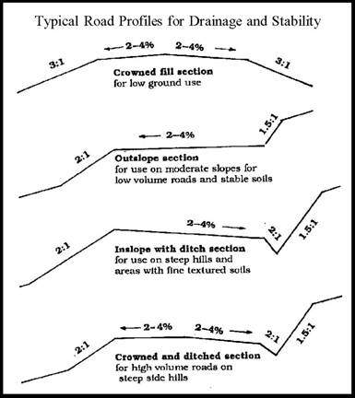

Figure 3 Typical Broad Based Dip
