Albizia biological control - June 2024
Ellyn Bitume & Tracy Johnson
Institute of Pacific Islands Forestry, PSW Research Station, USDA Forest Service

Summary
Exploration for natural enemies of albizia (Falcataria falcata) started late in FY2015 with funding from USDA Forest Service and Hawaii Invasive Species Council. This research has focused on finding new biological control agents through sponsored trips to the tree’s native range (eastern Indonesia and Papua New Guinea) where it is grown for timber and agroforestry. Dr. Ellyn Bitume has since completed four trips to Indonesia and has nurtured collaborations with two universities. Our work in the native range has now shifted from geographically broad surveys to focus on the Moluccas, the highly biodiverse center of origin for albizia, where natural enemies of particular interest are found. We have collected and identified two species as potential biological control agents: a stem boring weevil and a leaf galling mite. This year we supervised a graduating master’s student and continue to supervise two technicians who are continuing research in Bogor and Ambon. Dr. Bitume will travel again to Indonesia in July 2024 to continue this collaboration. A well-established collaboration with the Landcare Research center in New Zealand is also progressing rearing and host-choice testing for the mite.

FY2023 Highlights
- Began the bioinformatics process to analyze the data obtained from next generation sequencing of albizia trees from Hawaii and the Pacific Islands
- Co-supervised a master’s student in Indonesia who has completed their master’s thesis and has two publications ready for submission
  - Morphology and molecular characteristics of the stem-boring weevil
  - Sexual dimorphism and morphometry of the stem-boring weevil
- Progress in understanding the biology and rearing of the stem-boring weevil

Background
Albizia (Falcataria falcata) is one of Hawaii’s worst invasive species because it overwhelms and degrades native ecosystems and threatens homes, businesses, and public infrastructure. Native to the Moluccas (Indonesia), New Guinea, New Britain, and the Solomon Islands, albizia was deliberately introduced to Hawaii in the early 1900s. Although albizia is valued commercially in Southeast Asia for its fast growth, shade, and nitrogen fixing ability, these same characteristics have helped it become invasive in forests and developed landscapes in Hawaii and other Pacific islands, where it is no longer used in commercial forestry. Large albizia infestations have grown in recent years in native forests, agricultural, and residential areas. These trees can dramatically increase soil nitrogen, facilitating invasion by other exotic weeds while suppressing native species. Albizia can grow rapidly to 40 m tall, shading out native plant competitors. Their shallow root systems leave them susceptible to uprooting, and their massive but weak branches break easily in high winds or with age. Large mature trees have formed closed canopies over hundreds of hectares, creating significant hazards in populated areas of eastern Hawaii Island, central and windward Oahu, and much of Kauai. These ecological and economic impacts have led to widespread efforts at mechanical and herbicidal control, however sustainable management of albizia will require biological agents that contribute to long term suppression of populations across large areas.
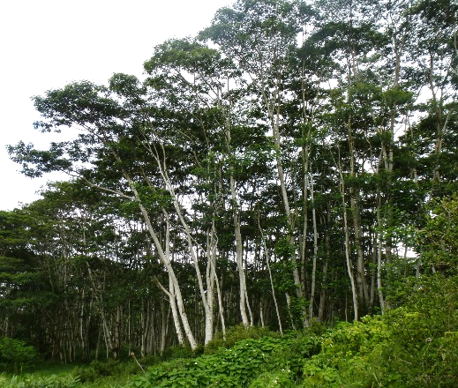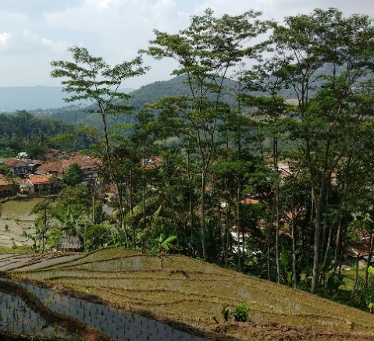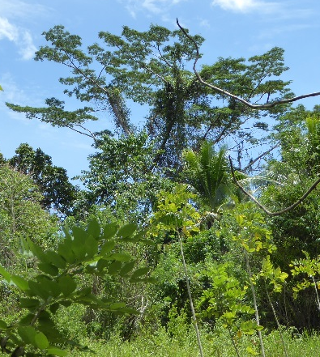
b
a
c
Figure 1: Albizia trees (a) invading ag lands in Mt. View, Hawaii; (b) in agroforestry with rice paddies in Java, Indonesia; and (c) as an isolated tree in its native range in the Molucca Islands, Indonesia.

Biological control of invasive plants has a long and successful history in Hawaii. Through careful, scientific screening, researchers have selected insects and pathogens that feed exclusively on target weed species to manage population abundance and spread. In Hawaii, surveys of the insects and diseases on invasive albizia trees reveal almost no herbivory limiting the plant. This contrasts starkly with the abundance of insect and disease damage observed during surveys in Papua New Guinea and Indonesia, where albizia is a minor part of the forest. The goal of biocontrol will be to identify host-specific natural enemies which can be released in Hawaii to restore some of the ecological balance exerted on albizia in its native range. Examples of successful biocontrol of Australian Acacia trees in South Africa, where they are invasive, further support the promise of this management option for albizia.

Update
Ambon, Maluku Province, Indonesia, is situated with ready access to many populations of native albizia and its natural enemies in diverse primary forests, secondary forest remnants and agroforestry plots. We now have official agreements in place to fund and coordinate work in Ambon between Pattimura University, IPB University in Bogor, and our Forest Service Pacific Southwest Research Station. We have successfully transferred another round of funds to support the project and were able to retain two technicians. We hope to hire a new master’s student in August 2024.

A master’s student at IPB in Bogor, Petra Bunga, has completed her research project focusing on the stem boring weevil. The main goal of this project was to identify the morphology and molecular characteristics of the weevil. She will submit two manuscripts: one on the morphology and molecular characteristics of the stem-boring weevil and the other on sexual dimorphism and morphometry of the stem-boring weevil. Finally, she was able to determine that the weevil has four larval instars and published her findings:

P B U Sitanggang, P Hidayat, Y M Kusumah, J A Leatemia, E V Bitume and M T Johnson 2023. Larval instars determination for the twig borer weevil (Coleoptera: Curculionidae) of Falcataria moluccana (Miq.). Barneby & Grimes in Moluccas, Indonesia, IOP Conf. Ser.: Earth Environ. Sci. 1271 012016

Figure 2: Ithyporini Gen. sp. Weevil attack on albizia. (A) Attacked branches, (B) exit hole of adult weevil, (C) bored branches, (D) pupa inside branch, (E) larvae, (F) adult.
We have focused heavily on quantifying and describing the biology of the weevil. We are now able to identify attack symptoms on trees in the field without having to open branches, which makes it easier to detect the presence of the weevil (Figure 2, A, B). In the lab and in controlled outdoor conditions, we are improving our rearing techniques of transferring larvae into new branches to continue their development (Figure 3). We have over 350 young albizia trees of various ages to conduct experiments to answer the question of what size and age of tree is best to ensure larval survival. We have also begun the construction of a new greenhouse at the University of Pattimura campus.

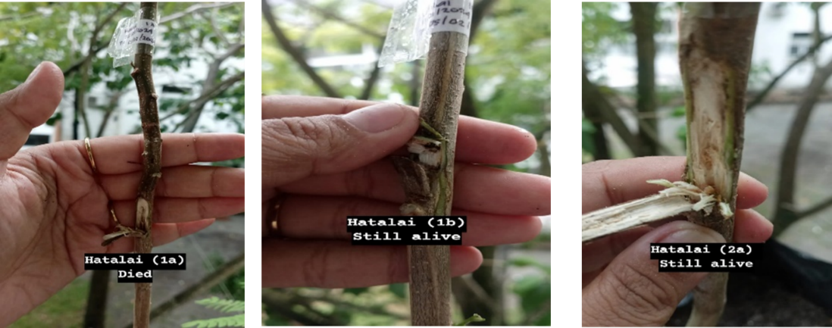

Figure 3: A representation of larval status after transfer into new stems of alive potted plants to continue their development.

A

Figure 4: (A) Greenhouse construction in progress on the university of Pattimura campus, (B-D) young albizia trees in various stages of development

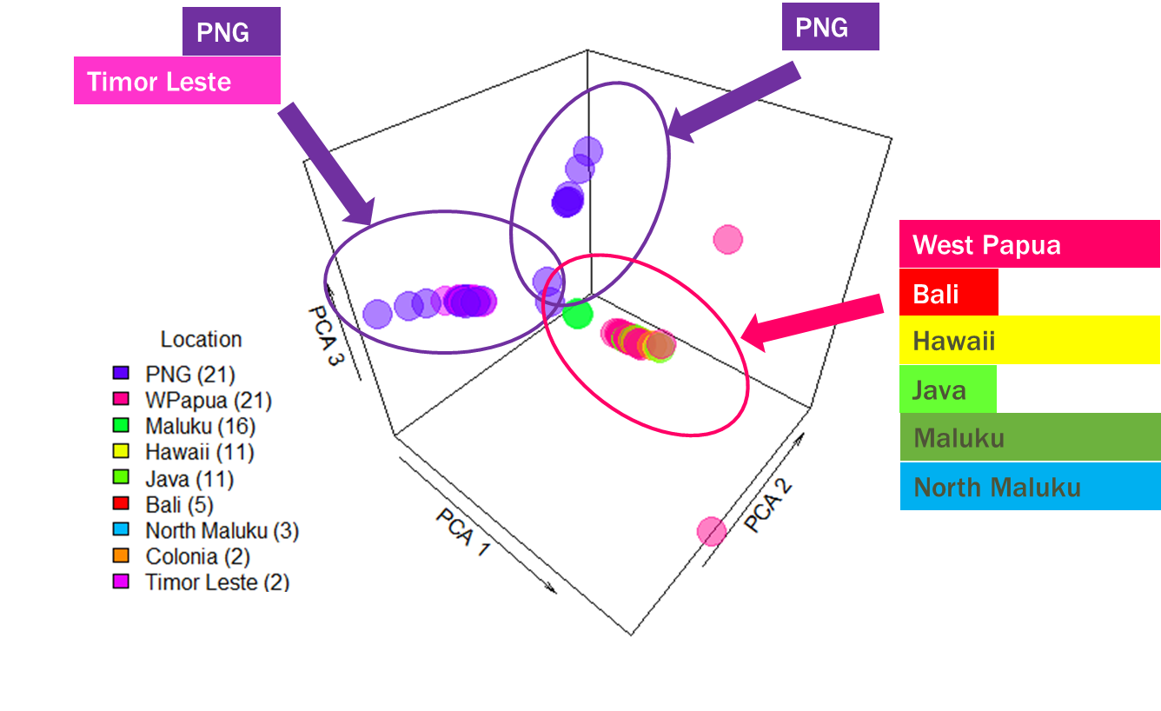
Figure 5: PCA analysis of 96 samples of albizia trees from the Pacific Islands and Hawaii

Bioinformatics is now more applicable than ever in biological control programs. By narrowing down the location of the native range of the invasive trees in Hawaii, we can better center our efforts to find tightly linked natural enemies that might be the most host specific. Furthermore, genetic information can reveal potential evolutionary mechanisms that allow the invasive tree to thrive in the novel environment. Following on efforts by IPIF’s Ken Puliafico and Nancy Chaney, we are collaborating with the University of Minnesota’s Genetics Center to use next-gen sequencing to answer larger questions about albizia’s phylogeny and look at levels of genetic diversity in several albizia populations.

We completed next-generation sequencing of 96 samples of albizia from the Pacific Island region and from Hawaii. Analysis of this data revealed that the trees from Hawaii are mostly closely related to trees from the Maluku region of Indonesia, where we have primarily conducted field surveys for biocontrol agents of the tree (Figure 5). Interestingly, the analysis also revealed a potential sub-species of albizia found in Papua New Guinea. Phenotypic data has suggested a sub-species of albizia in highland regions and our genetic results support this conclusion. In FY2025 we intend to submit another 96 samples of albizia to increase the robustness of our genetic results and lead to more specific conclusions.

We continue our collaboration with the Landcare Research center in New Zealand, where a plant pathologist is studying Uromycladium falcatarium, a gall-forming rust fungus that causes severe damage to albizia trees in Indonesia. With the help of a collaborator residing in Papua New Guinea, the team is starting work on the eriophyid mite. They have successfully obtained permits from the New Zealand government that allows the import of seeds of potential host plants from Hawaii. Our initial goals are (1) to determine if we can rear the mite in a quarantine facility, (2) to determine if surveyed damage is caused by one or more mite species, and (3) to begin host specificity testing of the mite.

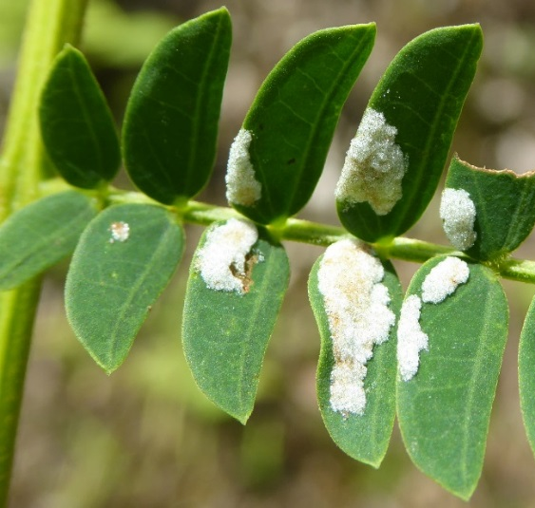
Figure 6: Leaflet galls caused by eriophyid mites found in Molucca Islands

Future work
Next year (FY2025) we will continue working with our partners in Indonesia to find and test potential biocontrol agents. We have two research teams: Dr. Purnama Hidayat at IPB Bogor and Dr. Audrey Leatemia at Pattimura University with two technicians. Dr. Bitume will visit Indonesia in July 2024 and again in January/February 2025. The two teams, coordinated by Dr. Bitume at the Forest Service, will continue to grow albizia plants in Hawaii and establish field sites in Indonesia where experiments will eventually be conducted. Dr. Bitume will focus on several aspects of the project that can be completed domestically. Her main goals are to (1) Develop techniques for propagating albizia needed for rearing biocontrol agents in quarantine in Hawaii; (2) Develop lab rearing techniques for the albizia stem weevil; (3) Supervise experiments in Indonesia focused on biology and host-specificity of potential biocontrol agents; (4) Supervise surveys to discover natural enemies affecting reproduction of albizia; and (5) Interpret genetic analyses to better target albizia’s native range and establish the origin of trees in Hawaii.

Collaborating Institutions and Other Cooperators
Indonesia
Institut Pertanian Bogor (IPB University), Bogor, West Java
Universitas Pattimura, Ambon, Maluku
New Zealand
Landcare Research Center, Lincoln

Melastome Biocontrol Update

Our Forest Service unit has continued to develop new biocontrol agents for invasive miconia, clidemia, tibouchina and related plants, all in the family Melastomataceae, and all alien to Hawaii. We continue to support State of Hawaii colleagues with information about the proposed releases of a Costa Rican butterfly whose larvae feed on miconia leaves, and a Brazilian beetle which feeds on tibouchina and its close relatives. New populations of the beetle were imported in 2023 to replace a quarantine colony lost due to work interruptions during the 2018 eruptions and the later pandemic. These were screened to eliminate possible hitch-hiking natural enemies and subjected to host-specificity tests to verify comparability to previous tests of this species over a decade ago. Results were consistent with previous findings showing a host range restricted to the tribe Melastomeae, which are all invasive. One of our newly sampled populations of the beetle Syphraea uberabensis shows ability to develop on an additional species, Tibouchina urvilleana (recently renamed Pleroma urvilleanum), which was not a fully suitable host plant in previous tests. This biocontrol agent enables new opportunities to manage all tibouchinas in Hawaii, as well as Melastoma species, and other related weeds.
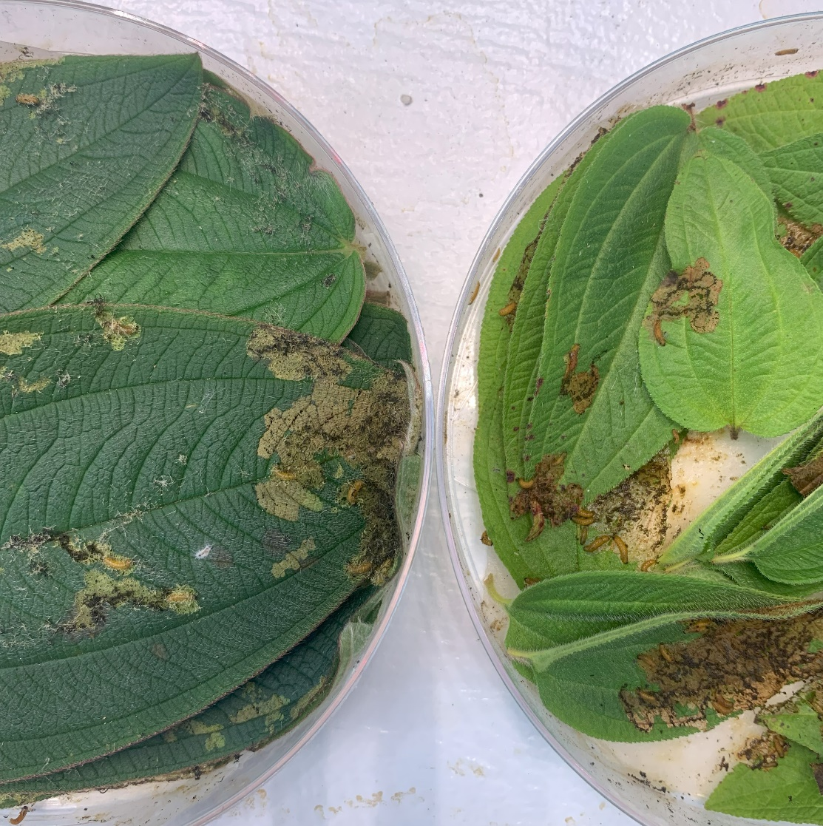

Larvae of Syphraea uberabensis reared in the Volcano quarantine following importation from Brazil. On the left a population which completes its life cycle on Tibouchina urvilleana; on the right a population which feeds and develops on Tibouchina herbacea (but is not well adapted to T. urvilleana).

Biocontrol of Himalayan Raspberry and Himalayan Ginger

Efforts continue to discover and evaluate natural enemies of Rubus ellipticus, Rubus niveus, and the invasive ginger Hedychium gardnerianum. These projects, led by collaborators in the United Kingdom, have been hampered by ongoing difficulties in securing research permits in India, where previous surveys identified several promising, potentially host-specific enemies. The hope is that access can be regained in 2025.

