State of Hawaii
DEPARTMENT OF LAND AND NATURAL RESOURCES
Division of Forestry and Wildlife (DOFAW)
Honolulu, Hawaiʻi 96813

January 27 and 28, 2021

Endangered Species Recovery Committee
State of Hawaii
Honolulu, Hawaiʻi

Committee Members:

SUBJECT: Request for recommendations from the Endangered Species Recovery Committee on all current Habitat Conservation Plans (HCPs), Safe Harbor Agreements (SHAs), and Incidental Take Licenses (ITLs). The status of HCPs and the Kamehameha SHA will be presented by license-holders for the 2020 fiscal year (July 1, 2019 – June 30, 2020). The status of the remaining SHAs for FY 2020 are to be presented by DOFAW.

CHAPTER 195D
Under Hawai‘i Revised Statute (HRS) §195D, Conservation of Aquatic Life, Wildlife, and Land Plants, an Endangered Species Recovery Committee (ESRC) was authorized and §195D-25 requires that the ESRC “Review all habitat conservation plans, safe harbor agreements, and incidental take licenses on an annual basis to ensure compliance with agreed to activities and, on the basis of any available monitoring reports, and scientific and other reliable data, make recommendations for any necessary changes.”

Contents

SUMMARY OF INCIDENTAL TAKE STATUS FOR ENDANGERED WILDLIFE SPECIES COVERED BY HABITAT CONSERVATION PLANS AND SAFE HARBOR AGREEMENTS 2
SUMMARY OF HABITAT CONSERVATION PLANS AND ASSOCIATED INCIDENTAL TAKE LICENSES BY PROJECT TYPE 7
Wind Energy Facilities and Structures 7
Kaheawa Pastures Wind Energy Generation Facility (KWP I) Habitat Conservation Plan, Maui, Hawai‘i. Approved 2006. 7
Kaheawa Wind Power II Wind Energy Generation Facility (KWP II) Habitat Conservation Plan, Maui, Hawai‘i. Approved 2012. 10
Auwahi Wind Energy Habitat Conservation Plan, Maui, Hawai‘i. Approved 2012. 13
Kahuku Wind Power Habitat Conservation Plan, O‘ahu, Hawai‘i. Approved 2010. 17
Kawailoa Wind Power Habitat Conservation Plan, O‘ahu, Hawai‘i. Approved 2012. 20
Nā Pua Makani Wind Energy Project Habitat Conservation Plan, O‘ahu, Hawai‘i. Approved 2019. 24
Transportation Projects 25
Relocation of Abutilon menziesii Habitat Conservation Plan, Kapolei, O‘ahu. Approved 2004. 25
Other Development Projects 28
Cyanotech Aquaculture Facility Habitat Conservation Plan, Keahole Point, Hawai‘i. Approved 2003. 28
Kaua‘i Lagoons (Hōkūala) Habitat Conservation Plan, Kaua‘i, Hawai‘i. Approved 2012. 30
Relocation of Round-leaved Chaff Flower (Achyranthes splendens var. rotundata) Habitat Conservation Plan, Kenai Industrial Park, Kapolei, O‘ahu, Hawai‘i. Approved 2014 33
Kaua‘i Seabird Habitat Conservation Plan, Kaua‘i Island, Hawai‘i. Approved 2020. 35
SUMMARY OF SAFE HARBOR AGREEMENTS AND ASSOCIATED INCIDENTAL TAKE LICENSES 37
Safe Harbor Agreement for Puʻu o Hōkū Ranch, Molokaʻi. 37
Programmatic Safe Harbor Agreement for Nēnē, Molokaʻi. 38
Safe Harbor Agreement for the Introduction of Nēnē to Piʻiholo Ranch, Maui. 39
Safe Harbor Agreement for the Reintroduction of Nēnē to Haleakalā Ranch, Maui. 41
Safe Harbor Agreement for the Koloa Maoli or Hawaiian Duck (Anas wyvilliana) and the Nēnē or Hawaiian Goose (Branta sandvicensis) on ʻUmikoa Ranch, Hawaiʻi Island. 42
Safe Harbor Agreement for Kamehameha Schools, Keauhou and Kīlauea Forest Lands, Hawaiʻi Island 43

SUMMARY OF INCIDENTAL TAKE STATUS FOR ENDANGERED WILDLIFE SPECIES COVERED BY HABITAT CONSERVATION PLANS AND SAFE HARBOR AGREEMENTS

Locations for the 12 Habitat Conservation Plans (HCPs) with Incidental Take Licenses (ITLs) are shown in Figure S1.
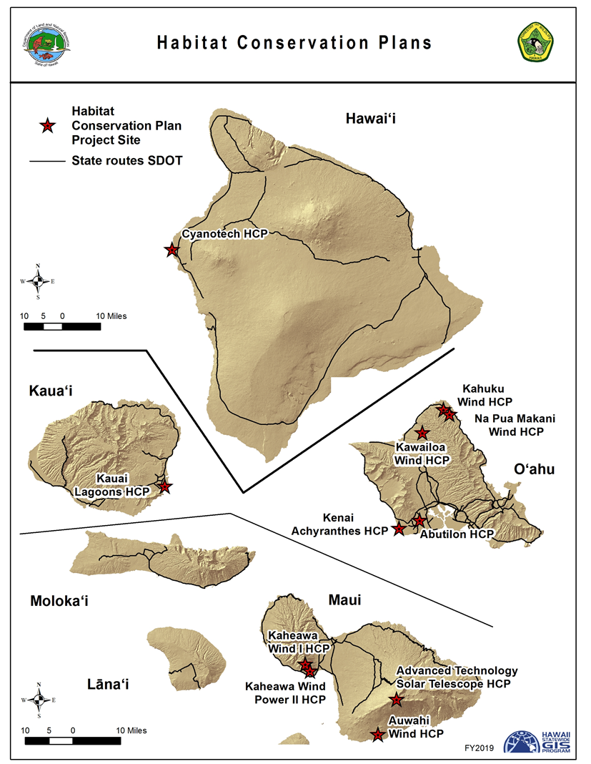
Figure S1. Habitat Conservation Plan Locations. The Kaua‘i Seabird HCP is island-wide and is not shown at a specific location.

Locations for 5 Safe Harbor Agreements (SHAs) with Incidental Take Licenses (ITLs) are shown in Figure S1.
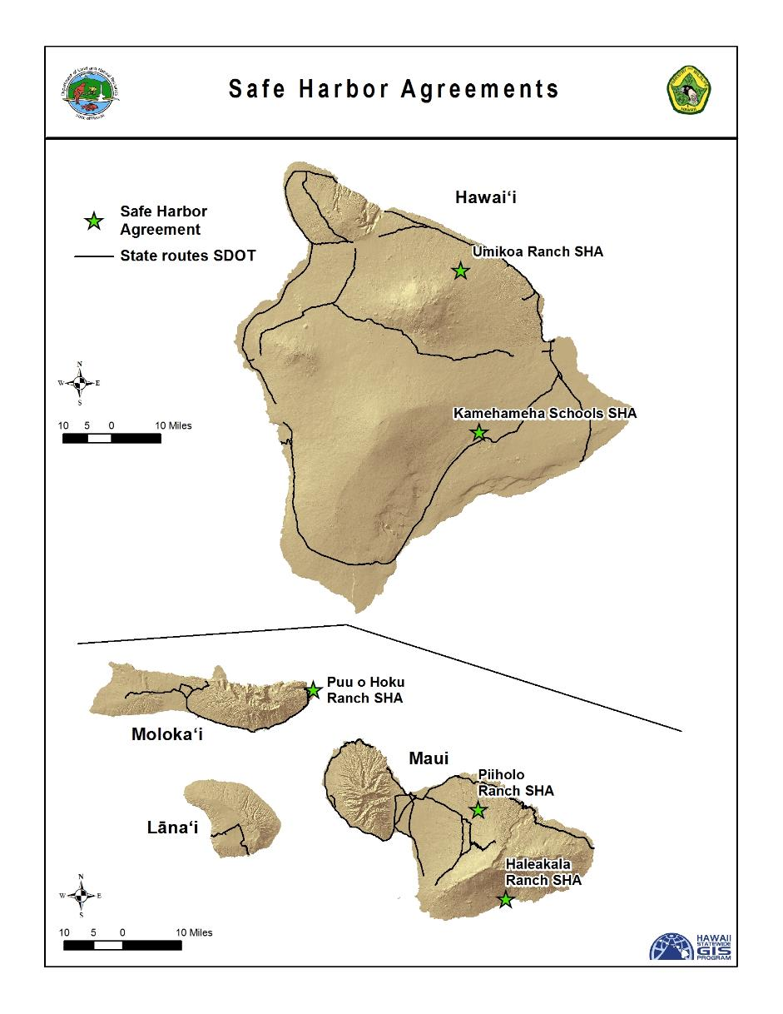
Figure S2. Location of Safe Harbor Agreements

To facilitate review by the ESRC this document summarizes information from the required annual reports (on a fiscal year basis) submitted by holders of ITLs associated with the 12 HCPs. In Fiscal Year (FY) 2020, the first annual reports were received for one new HCP approved project, the Kaua‘i Seabird HCP with an ITL effective date of June, 2020.

A summary of permit status combining take of all covered species of wildlife since ITLs were issued is depicted in Figure S3. The incidental take shown combines observed, modeled, and indirect take to estimate a total take as of the end of FY 2020.

In FY 2020, there were a total of 11 documented fatalities (incidental takes) of covered species detected in official fatality searches. Of these fatalities there were 5 Hawaiian Hoary Bats, 3 Nēnē, 2 Hawaiian Moorhens, and 1 Hawaiian Coot. At Auwahi Wind Project, 3 additional bat fatalities were discovered outside of official searches and one injured bat, found on an official search, was successfully released into the wild following rehabilitation. A Band-rumped Storm Petrel fatality was also documented at the Auwahi Wind Project, an endangered species which is not a covered species under the current HCP.

Subsequent to the end of FY 2020 and through December 1 2020, there was an additional 4 fatalities documented of Hawaiian Hoary Bats at Auwahi Wind Project and 1 at the Kahuku Wind Project. In the same time frame, there was 2 Hawaiian Ducks and 1 Hawaiian Moorhen fatality at Hōkūala and one Hawaiian Petrel fatality at Nā Pua Makani, which is a species not covered under their current HCP. Mitigation for take of covered species is ongoing and involves projects throughout Hawai‘i.

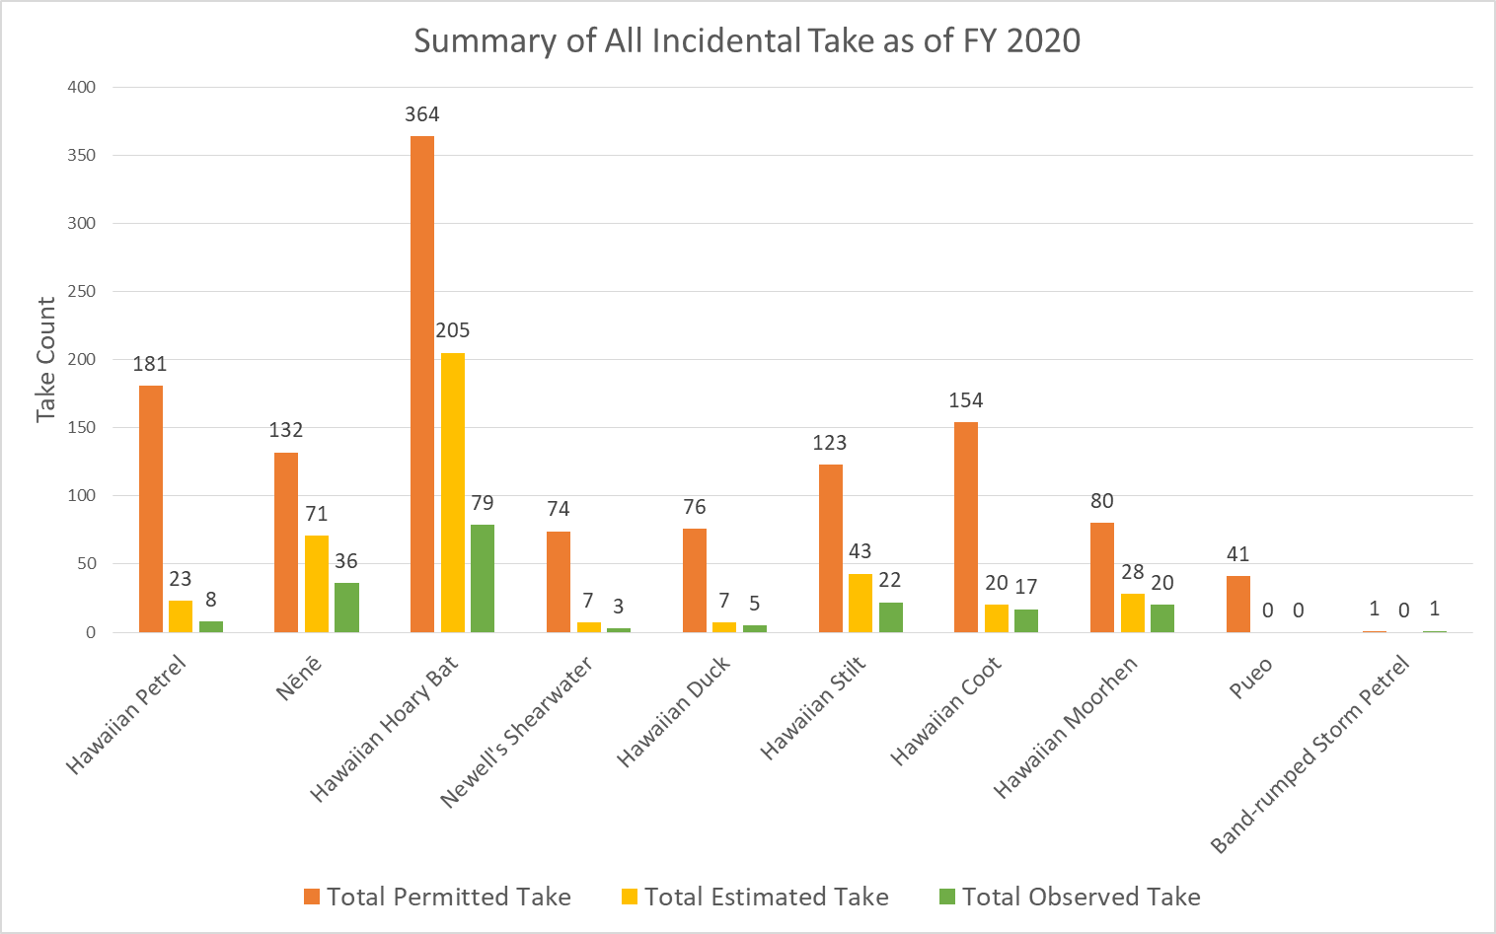
Figure S3. Total permitted take, observed take, and estimated take (includes indirect take and, for wind energy sites, modeled unobserved take at the 80% upper confidence level) of HCP-covered wildlife species for all approved HCPs as of June 30, 2020.

Hawaiian Hoary Bat Summary

Total estimated fatalities of the Hawaiian Hoary Bat for all approved HCPs, separated for the islands of Maui and Oahu are shown in Figure S4.

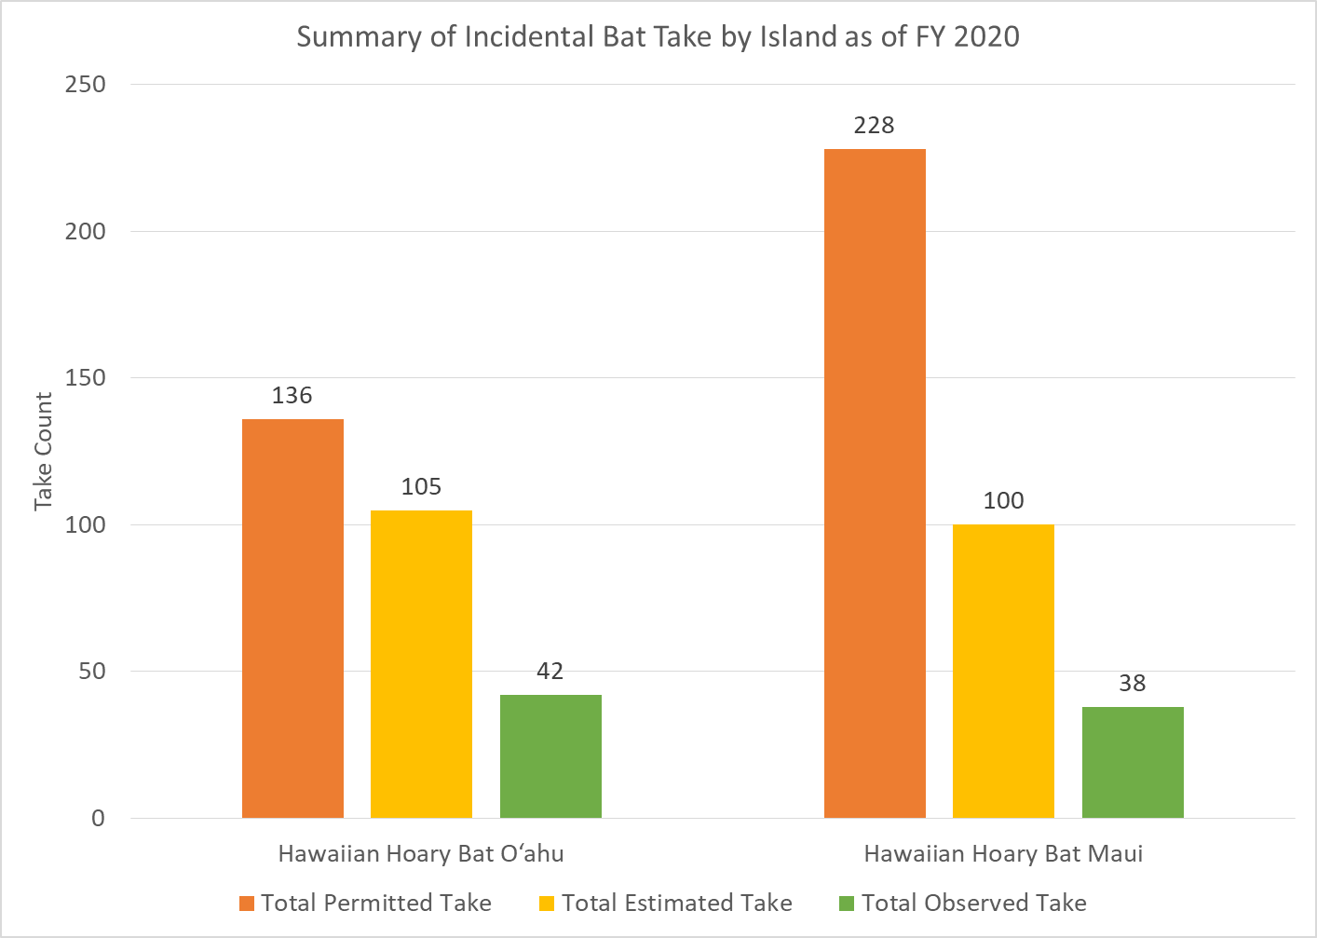
Figure S4. Total permitted take, observed take, and estimated take (includes indirect take and, for wind energy sites, modeled unobserved take at the 80% upper confidence level) for the Hawaiian Hoary Bat for approved HCPs on O‘ahu and Maui as of June 30, 2020.

Table S1. Hawaiian Hoary Bat HCP Summary as of FY 2020.

SUMMARY OF HABITAT CONSERVATION PLANS AND ASSOCIATED INCIDENTAL TAKE LICENSES BY PROJECT TYPE

Wind Energy Facilities and Structures

Kaheawa Pastures Wind Energy Generation Facility (KWP I) Habitat Conservation Plan, Maui, Hawai‘i. Approved 2006.
Kaheawa Wind Power project in West Maui above Ma‘alaea.
ITL Licensee: Kaheawa Wind Power, LLC
(Terraform Power owns KWP, LLC)

Project: Twenty wind turbine generators (WTGs) with a total 30-megawatt (MW) energy generating capacity

ITL Duration: January 30, 2006 – January 30, 2026 (72% through the permit term as of the end of FY 2020)

Take Authorization Over 20-year Term:

Table 1. Take Authorization for KWP I.
Common Name | Scientific Name | Baseline Limit  (Tier 1)¹ | Higher Limit  (Tier 2)¹
‘Ua‘u or Hawaiian Petrel | Pterodroma sandwichensis | 25 | 38
‘A‘o or Newell’s Shearwater | Puffinus auricularis newelli | 4 | 8
Nēnē or Hawaiian Goose | Branta sandvicensis | 60 | n/a
‘Ōpe‘ape‘a or Hawaiian Hoary Bat | Lasiurus cinereus semotus | 20 | 50ª
¹ Take authorization is delineated by Baseline and Higher Limits (Tiers). Upon reaching Higher Limits additional mitigation measures or funding are triggered to ensure that mitigation keeps pace with take.
ª This higher limit for the Hawaiian Hoary Bat was approved by minor amendment in 2016.
Status of ITL: There was no take of HCP covered species during the reporting period (Table 2).

Table 2. Documented fatalities of HCP covered species during the reporting period.
Common Name | FY20 Fatalities
Nēnē | 0
Hawaiian Hoary Bat | 0
Hawaiian Petrel | 0
Beginning in April 2015, the downed wildlife search area was reduced relative to the previous ten years and now consists of graded roads and WTG pads found within a 70-meter radius circle centered on each turbine. Beginning in October 2015, canine-assisted searching was implemented, with visual searching as a secondary method. In FY 2020, all searches were performed by a canine-assisted team.

In October 2019, wildfires destroyed bat monitoring equipment at the wind turbines and as a result the number of ground based acoustic detectors was reduced from nine to five.
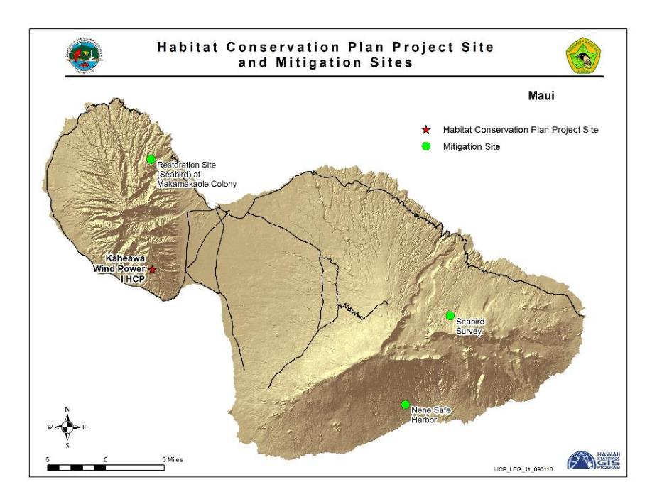
Figure 3. Location of Kaheawa Wind Power I HCP and Mitigation Sites
Table 3 provides an estimate of the overall total adjusted take that has occurred since KWP I ITL issuance. The take rate through FY 2020 for all covered species would keep the project under the permitted take.
In addition to the total estimated take, accrued lost productivity from mortality of individuals due to the lag in mitigation are also evaluated and mitigated for, but are not counted against permitted take levels. Accrued lost productivity calculations for Hawaiian Petrel and Nēnē are pending at the time of this report. Although not listed as endangered on Maui it is noteworthy that 16 fatalities of the Hawaiian Short-eared Owl (Pueo) have been reported in the KWP I project vicinity since the ITL was issued, all prior to FY 2020. Reports indicate that the majority of the fatalities, not necessarily all, are due to project operations.
Table 3. Total observed fatalities and estimated total take since ITL issuance under the KWP I ITL as of June 30, 2020.
Common Name | Total Observed Take¹ | Estimated Unobserved Take² | Indirect Take using HCP multipliers | Total Estimated Take
Hawaiian Petrel | 7 | 8 | 4 | 19
Nēnē | 25 | 18 | 2 | 45
Hawaiian Hoary Bat | 9 | 17 | 4 | 30
1 Excludes takes that were incidental and not observed during systematic monitoring (incidental takes are evaluated as part of the EoA modeling software and therefore accounted for in the unobserved take).
2 Based on the 80% credible maximum using the following model: Dalthorp, D., M. M. P. Huso, and D. Dail. 2017. Evidence of absence (v 2.0) software user guide: U.S. Geological Survey Data Series 1055.

Mitigation Status:

Hawaiian Petrel & Newell’s Shearwater. Mitigation for the two seabird species (Hawaiian Petrel and Newell’s Shearwater) is being implemented in conjunction with Kaheawa Wind Power II. The primary mitigation entails management of two constructed (approximately four acres) predator-free fenced enclosures (one for each species), provisioned with artificial burrows and social attraction, at the Makamaka‘ole site in West Maui. Three species of seabirds, Hawaiian Petrel, Newell’s Shearwater, and Bulwer’s Petrel or ‘Ou (Bulweria bulwerii), have frequented burrows within both enclosures between the months of March and October since June 22, 2015. Only Newell’s Shearwater nesting activity has been observed in FY 2020.

Work in FY 2020 at Makamaka‘ole included predator trapping and tracking, ongoing maintenance of both enclosures, artificial burrow checks, and game camera operation.
Traps and bait stations were deployed and a total of 37 mongooses, 20 rats, and three mice were captured. All of the mongooses were captured outside the enclosures while ten of the rats and all three mice were captured inside the enclosures. Barn Owls were observed during night surveys on five occasions in in FY 2020 and Barn Owl control was conducted on three occasions, but no owls were shot or removed.

To mitigate for the loss of productivity accrued from Hawaiian Petrel estimated take not yet mitigated for at Makamaka‘ole, Hawaiian Petrel nesting colony management and predator control by Pūlama Lāna'i on Lāna'i Island was conducted during FY 2020, from which 36 fledglings were produced.

Nene. Nēnē baseline mitigation continued through funding operation of the Haleakalā Ranch pen in FY 2020. Management at the pen included: monitoring; vegetation management; fence, pond, and infrastructure maintenance; road improvements; and predator control. Forty one traps were deployed in FY 2020 which captured six mongooses and one mouse. Nēnē fledgling production in FY 2020 credited to KWP I was ten goslings.

Hawaiian Hoary Bat. Baseline mitigation for 20 bats was funded in 2006 and is complete. A mitigation project accounting for take of an additional 15 bats was completed and a final report submitted in FY 2020 for a total contract cost of $750,000. This mitigation project consisted of Hawaiian Hoary Bat ecological research in East Maui, contracted to H.T. Harvey Ecological Consultants, and evaluated the species’ habitat preferences, prey availability, foraging ranges, core use areas, and diet over 34,226 hectares on Haleakalā. Bat detectors were installed at 45 sites in nine habitat types for a total of 315 deployments. To radio tag bats, mist netting occurred from June 2017 through September 2018 in three general areas: Haleakalā National Park, Olinda Road, and Lower Kula. H.T. Harvey researchers radio-tracked 16 bats on 109 nights during the mist netting period, and sampled insects in the nine habitat types for seven sampling periods from August 2017 through August 2018. From the acoustic data it was determined bats spent more time foraging in gulch, low-density developed, and grassland habitats, although differences existed between months.

The study showed bats were much less likely to call on nights with rainfall. The mean core use area used by the bats for foraging was 3,700 hectares, but there was a wide range of values among individual bats. The majority of guano samples were collected from adult males, adult females, and subadult females, and showed bats ate primarily moths (68%), as well as flies (12%), termites (9%), crickets and katydids (5%), beetles (4%), and true bugs (2%). Insects eaten were both native and non-native, and the dietary data suggested the bats were somewhat selective in their prey choices when compared to the abundance of insect species available in the insect samples. Finally, the results demonstrated the Hawaiian Hoary Bats on Maui were able to forage in different habitats during different seasons.

KWP I is also partially funding another Hawaiian Hoary Bat ecological research project on Hawai‘i Island contracted to the U.S. Geological Survey Hawaiian Hoary Bat Research Group that began in FY 2018. The project contribution to this contract will be $750,000 and accounts for take of the remaining 15 bats. This mitigation project is studying movements, roosting behavior, and diet of the Hawaiian Hoary Bat, and is expected to be completed in FY 2021.

Kaheawa Wind Power II Wind Energy Generation Facility (KWP II) Habitat Conservation Plan, Maui, Hawai‘i. Approved 2012.
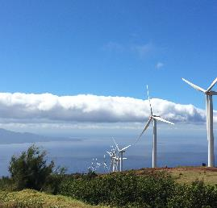
Kaheawa Wind Power II project in West Maui above Ma‘alaea.
ITL Licensee: Kaheawa Wind Power II, LLC
(Note that Terraform Power owns KWP II, LLC)

Project: Fourteen WTGs with a total 21-MW energy generating capacity. Project is adjacent and downslope of KWP I

ITL Duration: January 5, 2012 – January 30, 2032 (42 % through the permit term as of the end of FY 2020)

Take Authorization Over 20-year Term:

Table 4. Take Authorization for KWP II.
Common Name | Scientific Name | Level of Take¹ | 5-year Limit | 20-year Limit
‘Ua‘u or Hawaiian Petrel | Pterodroma sandwichensis | Tier 1 | 8 adults/ juveniles & 4 chicks/eggs | 19 adults/ juveniles & 9 chicks/eggs
‘Ua‘u or Hawaiian Petrel | Pterodroma sandwichensis | Tier 2 | 16 adults/ juveniles & 8 chicks/eggs | 29 adults/ juveniles & 14 chicks/eggs
‘A‘o or Newell’s Shearwater | Puffinus auricularis newelli | Tier 1 | 2 adults/ juveniles & 2 chicks/eggs | 2 adults/ juveniles & 2 chicks/eggs
‘A‘o or Newell’s Shearwater | Puffinus auricularis newelli | Tier 2 | 5 adults/ juveniles & 3 chicks/eggs | 5 adults/ juveniles & 3 chicks/eggs
Nēnē or Hawaiian Goose | Branta sandvicensis | Tier 1 | 8 adults/ juveniles & 1 fledgling | 18 adults/ juveniles & 3 fledglings
Nēnē or Hawaiian Goose | Branta sandvicensis | Tier 2 | 12 adults/ juveniles & 3 fledgling | 27 adults/ juveniles & 3 fledgling
Nēnē or Hawaiian Goose | Branta sandvicensis | Tier 3³ | Not applicable | 44 adults
‘Ōpe‘ape‘a or Hawaiian Hoary Bat² | Lasiurus cinereus semotus | Tier 1 | 7 individuals | 7 bats
‘Ōpe‘ape‘a or Hawaiian Hoary Bat² | Lasiurus cinereus semotus | Tier 2 | 11 individuals | 11 bats
‘Ōpe‘ape‘a or Hawaiian Hoary Bat² | Lasiurus cinereus semotus | Tier 3³ | Not applicable | 30 bats
‘Ōpe‘ape‘a or Hawaiian Hoary Bat² | Lasiurus cinereus semotus | Tier 4³ | Not applicable | 38 bats
¹ Take authorization is delineated by Tiers. Upon reaching higher Tiers additional mitigation measures or funding are triggered to ensure that mitigation keeps pace with take.
² Minor amendment to clarify permitted bat take processed on November 26, 2014.
³ New tier approved in a major amendment on November 8, 2019.
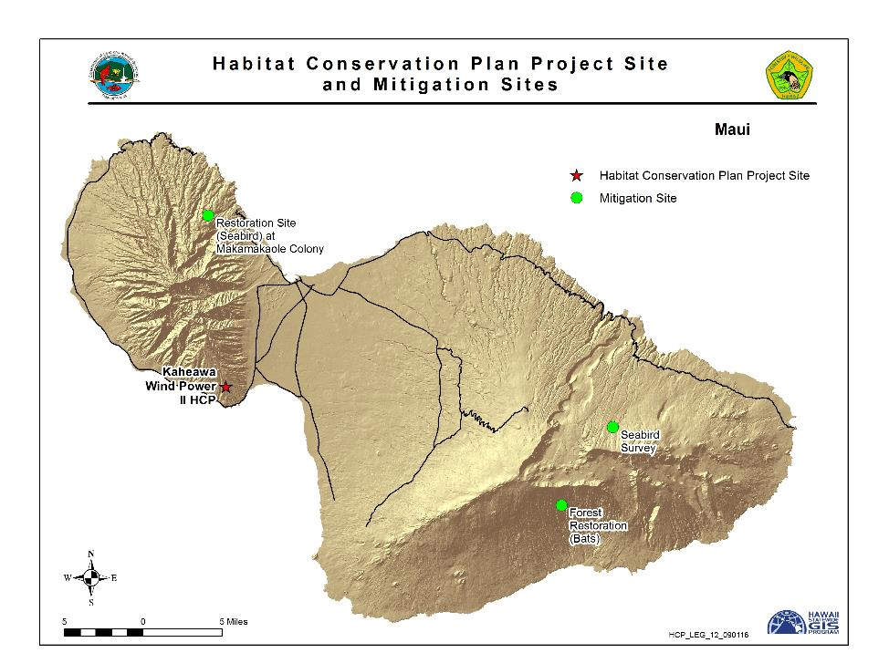
Figure 4. Location of Kaheawa Wind Power II HCP and Mitigation Sites

Status of ITL: Table 5 provides a listing of the HCP covered species fatalities during the reporting period. Three Nēnē fatalities were observed in FY 2020 within the designated search area.
Table 5. Documented fatalities of HCP covered species during
the reporting period.
Common Name | FY20 Fatalities
Nēnē | 3

The incidental take authorized includes both observed and unobserved take, including indirect take that occurs when an adult individual is taken during its respective breeding season. Table 6 provides an estimate of the overall total adjusted take that has occurred since KWP II ITL issuance. In addition to the total estimated take, accrued lost productivity from mortality of individuals due to the lag in mitigation are also evaluated and mitigated for, but are not counted against permitted take levels. Accrued lost productivity calculations for Nēnē are pending at the time of this report.
Beginning in July 2015 the search plot areas were reduced in size relative to the size of plots searched prior to July 2015. The reduced search area includes only roads and graded WTG pads found within a circle of radius 70 meters centered on each WTG. Canine-assisted searching in FY 2020 was the primary search method accounting for 100% of the downed wildlife monitoring searches.
In October 2019 wildfires destroyed bat monitoring equipment at the wind turbines and as a result the number of ground based acoustic detectors was reduced from eight to five.

Table 6. Total observed fatalities and estimated total take since ITL issuance covered under the KWP II ITL as of June 30, 2020.
Common Name | Total Observed Take¹ | Estimated Unobserved Take² | Indirect Take using HCP multipliers | Total Estimated Take
Nēnē | 8 | 13 | 2 | 23
Hawaiian Hoary Bat | 3 | 8 | 1 | 12
1 Excludes takes that were incidental and not observed during systematic monitoring (incidental takes are evaluated as part of the EoA modeling software and therefore accounted for in the unobserved take).
2 Based on the 80% credible maximum using the following model: Dalthorp, D., M. M. P. Huso, and D. Dail. 2017. Evidence of absence (v 2.0) software user guide: U.S. Geological Survey Data Series 1055
As the total estimated take of 12 bats (with 80% statistical certainty) exceeds both the Tier 1 and Tier 2 permitted take levels for bats, and take of Nēnē (with 80% statistical certainty and indirect take) has been occurring at a rate that could exceed both Tier 1 and Tier 2 permitted take levels for Nēnē, KWP II submitted an amended HCP and associated ITL to the agencies for review in FY 2020. The amendment added an additional tier of Nēnē take and an additional two tiers of bat take. The amended HCP was approved on November 8, 2019 and the adjusted take authorization can be found in Table 4.

Mitigation Status:

Hawaiian Petrel and Newell’s Shearwater. Mitigation for the two seabird species (Hawaiian Petrel and Newell’s Shearwater) is being implemented in conjunction with Kaheawa Wind Power I. Tier 1 mitigation for estimated seabird take at the project continues at the Makamaka‘ole seabird enclosures. These efforts include trapping and monitoring for potential predators, maintenance of enclosure fences, erosion control, and monitoring seabird activity within the Makamaka‘ole Stream drainage area and near artificial burrows within the enclosures. Only Newell’s Shearwater nesting activity has been observed in FY 2020. Site surveys of an alternative seabird mitigation site, as required by the HCP, were completed in East Maui in FY 2016.

Nēnē. Nēnē mitigation has been contracted to DOFAW for Tier 1 estimated take in prior fiscal years for the Pi‘iholo Ranch Nēnē pen, and in conjunction with KWP I at the Haleakalā Ranch Nēnē pen; however, in Fiscal Year 2020 no funding was provided for either pen by KWP II. KWP II will resume funding Pi‘iholo Ranch Nēnē pen in FY 2021.

Hawaiian Hoary Bat. In accordance with the KWP II HCP, baseline mitigation for the Hawaiian Hoary Bat was implementation of bat habitat improvement measures on at least 338 acres. Mitigation for Tier 1 and Tier 2 estimated bat take has been completely funded and continues as vegetation outplanting at Kahikinui State Forest Reserve. Mitigation for Tier 3 estimated take in the form of bat ecological research on Hawai‘i Island has been contracted. This work is intended to better inform future bat habitat restoration and conservation and began in FY 2018 by the U.S. Geological Survey Hawaiian Hoary Bat research group. This mitigation project is studying movements, roosting behavior, and diet of the Hawaiian Hoary Bat, and is expected to be completed in FY 2021.

Pueo. Although the Pueo is not a listed species on Maui, KWP II included Pueo in their HCP and provided mitigation compensation in the form of $25,000 paid to DOFAW in FY 2013 to be directed toward Pueo research efforts on O‘ahu. With these and other funds DOFAW funded a Pueo research project in 2017 on O‘ahu which was completed in FY 2018 and can be viewed at https://www.pueoproject.com.

Auwahi Wind Energy Habitat Conservation Plan, Maui, Hawai‘i. Approved 2012.

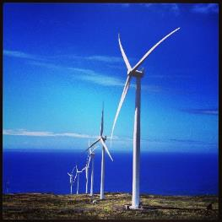
ITL Licensee: Auwahi Wind Energy, LLC (owned by American Electric Power Company, Inc.)
Auwahi Wind Power, Maui

Project: Eight WTGs with a total 21-MW energy generating capacity

ITL Duration: February 9, 2012 – February 9, 2037 (42% through the permit term as of the end of FY 2020)

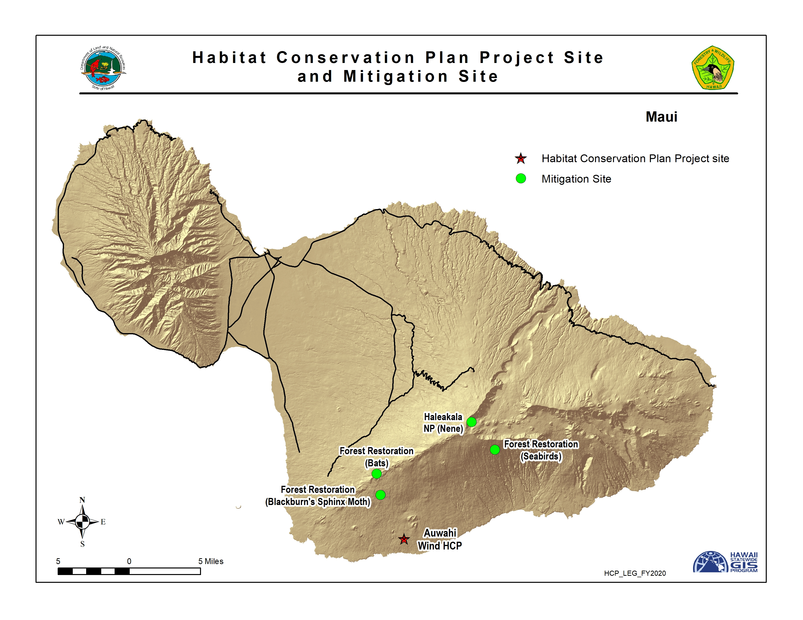
Figure 5. Location of Auwahi HCP and Mitigation Sites

Take Authorization Over 25-year Term:

Table 7. Take Authorization for Auwahi Wind HCP.
Common Name | Scientific Name | Level of Take | 25-year Limit
‘Ua‘u or Hawaiian Petrel | Pterodroma sandwichensis | Tier 1 | 19 adults/ immatures & 7 chicks/eggs
‘Ua‘u or Hawaiian Petrel | Pterodroma sandwichensis | Tier 2 | 32 adults/ immatures & 12 chicks/eggs
‘Ua‘u or Hawaiian Petrel | Pterodroma sandwichensis | Tier 3 | 64 adults/ immatures & 23 chicks/eggs
Nēnē or Hawaiian Goose | Branta sandvicensis | Length of permit | 5 adults/ immatures
‘Ōpe‘ape‘a or Hawaiian Hoary Bat¹ | Lasiurus cinereus semotus | Tier 1 | 5 bats
‘Ōpe‘ape‘a or Hawaiian Hoary Bat¹ | Lasiurus cinereus semotus | Tier 2 | 11 bats
‘Ōpe‘ape‘a or Hawaiian Hoary Bat¹ | Lasiurus cinereus semotus | Tier 3 | 21 bats
‘Ōpe‘ape‘a or Hawaiian Hoary Bat¹ | Lasiurus cinereus semotus | Tier 4² | 81 bats
‘Ōpe‘ape‘a or Hawaiian Hoary Bat¹ | Lasiurus cinereus semotus | Tier 5² | 115 bats
‘Ōpe‘ape‘a or Hawaiian Hoary Bat¹ | Lasiurus cinereus semotus | Tier 6² | 140 bats
Blackburn’s Sphinx Moth | Manduca blackburni | Not applicable | 28-acres permanently disturbed habitat is an index of take
¹ Take authorization for bats are converted to adult bats based on HCP and clarified by email from J. Charier of USFWS to Marie VanZandt of Auwahi on March 2, 2015.
² New tier approved in a major amendment on August 23, 2019.
Status of ITL: Table 8 provides a listing of HCP covered species fatalities at the Auwahi Wind Energy facility during FY 2020. Eight Hawaiian Hoary Bat fatalities were observed in FY 2020. Three of the Hawaiian Hoary Bats were found outside the designated search area. In addition, one injured Hawaiian Hoary Bat was found alive during a fatality monitoring search and was successfully recovered, rehabilitated, and released back into the wild. One Band-rumped Storm Petrel fatality was found during FY 2020, an endangered species not covered during the reporting period. Since this species is not currently covered, Auwahi is preparing an amendment to add this species and also reduce the Hawaiian petrel take due to lower take to date than anticipated.
Table 8. Documented fatalities of HCP covered species and species of concern at Auwahi during the reporting period.
Common Name | Scientific Name | FY20 Fatalities
Hawaiian Hoary Bat | Lasiurus cinereus semotus | 8
Band-rumped Storm Petrel | Oceanodroma castro | 1

In FY 2020, all weekly fatality monitoring searches were conducted by a canine-assisted search team along turbine pads and roads within a 100 meter radius of turbines and a 10 meter radius of the meteorological tower.

Table 9 provides an estimate of the overall total adjusted take that has occurred since Auwahi Wind ITL issuance.

Table 9. Total observed fatalities since ITL issuance and estimated total adjusted take covered under the Auwahi Wind Energy ITL as of June 30, 2020.
Common Name | Total Observed Take¹ | Estimated Unobserved Take² | Indirect Take | Total Adjusted Take
Hawaiian Hoary Bat | 25 | 27 | 6 | 58
Hawaiian Petrel | 1 | 2 | 1 | 4
Band-rumped Storm Petrel | 1 | ND | ND | ND
1 Excludes takes that were incidental and not observed during systematic monitoring (incidental takes are evaluated as part of the EoA modeling software and therefore accounted for in the unobserved take).
2 Based on the 80% credible maximum using the following model: Dalthorp, D., M. M. P. Huso, and D. Dail. 2017. Evidence of absence (v 2.0) software user guide: U.S. Geological Survey Data Series 1055.
ND - Not determined.

The total estimated take of bats exceeded the total permitted take for bats on the original ITL by June 2016 and Auwahi Wind submitted an amended HCP and associated ITL to the agencies for review in FY 2019, which added an additional three tiers of bat take and implemented low wind speed curtailment at 6.9 m/s. The amended HCP was approved in FY 2020 and the adjusted take authorization can be found in Table 7. During FY 2020 the rate of bat take exceeded the projected threshold required to be met in order to remain within the amended take limit over the remainder of the 25 year permit term. Auwahi Wind implemented its adaptive management plan and installed acoustic deterrents on all eight turbines in June and July 2020.
Mitigation Status:
Hawaiian Petrel. Mitigation for take of Hawaiian Petrels in FY 2020 (2019 breeding season) consisted of continued petrel burrow monitoring at Kahikinui Forest Reserve to obtain an estimate of the number of active petrel burrows and reproductive (fledging) success. Four new burrows located were marked, mapped, and added to the monitoring dataset. In the most recent breeding season, 76 petrel burrows were being monitored, 28 of which showed signs of consistent activity. Nine burrows successfully fledged a chick.
The predator control strategy continued to assess rat and mongoose activity across the entire management area. One hundred thirty five traps were deployed in FY 2020. Traps were checked and baited every two weeks and were operational year-round. Trapping resulted in the removal of 90 mice, 18 rats, and one mongoose.
Nēnē. Auwahi Wind provided a one-time payment of $25,000 to the Haleakalā National Park on April 17, 2012, to cover mitigation expenses for the Hawaiian Goose.

Hawaiian Hoary Bat. Tier 1 mitigation for the Hawaiian Hoary Bat consists of the restoration of approximately 132 acres of pastureland in the Waihou Mitigation Area (the Pu‘u Makua parcel) to create roosting and foraging habitat for the Hawaiian Hoary Bat. Restoration of this area included a perimeter fence and the removal of ungulates. The fence was inspected quarterly in FY 2020 and is in good condition. Invasive plant species control is continuing to meet success criteria targets and supplemental outplanting of native Hawaiian plants continued in the reporting period. FY 2020 (Year 5) monitoring of percent vegetative cover along all transects showed an overall percent cover of native woody vegetation of 27.7 percent, and non-native vegetation of 23.9 percent.

Tier 2 mitigation is completed. Auwahi worked with Frank Bonaccorso of the U.S. Geological Survey (USGS) to develop a research project combining radio telemetry and acoustic monitoring to track the success of mitigation efforts at Waihou, as well as to provide more information on the ecology of the Hawaiian Hoary Bat. Implementation of the plan began in March 2015 with the deployment of six acoustic detectors. Monitoring occurred under Tier 2 for one year and results have been reported previously.

The Tier 3 bat mitigation study conducted by the U.S. Geological Survey in the Pu‘u Makua Restoration Area within the Waihou mitigation area in east Maui is completed, and results were reported in FY 2019. Habitat use, diet, prey availability, and foraging ecology of the Hawaiian Hoary Bat was studied. Acoustic monitoring over the three-year period demonstrated that bats are present and actively forage year-round at the Waihou Mitigation Area. Over an 8-month span, 11 bats were uniquely color-banded and released, three of which were pregnant or lactating females, which highlights the importance of the area to breeding residents. The study confirmed the following insect groups, both native and non-native species, as prey items of the bat: Coleoptera, Lepidoptera, Diptera, Hemiptera, and Blattodea. Moths (Lepidoptera) were the primary dietary component which included 18 Lepidoptera families including 24 genus- or species-level taxa.

Tier 4 mitigation for the bat consists of protecting, managing, and enhancing 709 hectares of bat foraging and roosting habitat at ‘Ulupalakua Ranch, and planning work began in FY 2020. The 709 hectares of land will be placed in a conservation easement held by the Hawaiian Islands Land Trust and the final conservation easement is expected to be executed in FY 2021. The Project initiated insect and acoustic bat monitoring throughout the mitigation site in FY 2020 in preparation for management and enhancement actions.

As obligated in the approved HCP amendment, Auwahi Wind began funding a single year occupancy study of the Hawaiian Hoary Bat on Leeward Haleakalā during the reporting period. The study area spans from Ahihi-Kinau Natural Area Reserve to the Kaupō gap, and from the summit of Haleakalā to the coast. The results of the study are expected to be available in FY 2021.

Blackburn’s Sphinx Moth. Baseline mitigation for Blackburn’s Sphinx Moth consisted of a contribution of $144,000 to the Leeward Haleakalā Watershed Restoration Partnership in 2012, to restore dryland forest by planting the equivalent of six acres of native endangered ‘Aiea (Nothocestrum latifolium) throughout the Auwahi Forest Restoration Project. ‘Aiea is known to serve as a host plant for the endangered Blackburn’s Sphinx Moth. In FY 2019 the goal of planting 1,500 ‘Aiea plants on 11 acres was reached and Auwahi Forest Restoration Project fulfilled the MOU requirements. During FY 2020 11 tree tobacco (Nicotiana glauca) plants, a non-native invasive host plant for the moth, were removed from the wind farm site. No larvae were detected during visual surveys of tree tobacco in FY 2020.

Kahuku Wind Power Habitat Conservation Plan, O‘ahu, Hawai‘i. Approved 2010.

ITL Licensee: Kahuku Wind Power, LLC
Kahuku facility on the North Shore of O‛ahu.
(Note that Terraform Power owns Kahuku, LLC)

Project: Twelve WTGs with a total 30-MW energy generating capacity

ITL Duration: June 7, 2010 – June 7, 2030 (50% through the permit term as of the end of FY 2020)

Take Authorization Over 20-year Term:

Table 10. Take Authorization for Kahuku Wind HCP.
Common Name | Scientific Name | Level of Take¹ | Annual Take Limit² | 5-year Take Limit³ | 20-year Take Limit³
‘Ua‘u or Hawaiian Petrel | Pterodroma sandwichensis | Baseline | 4 | 8 adults/ juveniles | 8 adults/ juveniles
‘Ua‘u or Hawaiian Petrel | Pterodroma sandwichensis | Higher | 8 | 12 adults/ juveniles | 12 adults/ juveniles
‘A‘o or Newell’s Shearwater | Puffinus auricularis newelli | Baseline | 3 | 9 adults/ juveniles | 12 adults/ juveniles
‘A‘o or Newell’s Shearwater | Puffinus auricularis newelli | Higher | 6 | 12 adults/ juveniles | 18 adults/ juveniles
Koloa Maoli  or Hawaiian Duck | Anas wyvilliana | Baseline | 4 | 12 adults/ juveniles | 16 adults/ juveniles
Koloa Maoli  or Hawaiian Duck | Anas wyvilliana | Higher | 8 | 16 adults/ juveniles | 24 adults/ juveniles
Ae‘o or Hawaiian Stilt | Himantopus mexicanus knudseni | Baseline | 3 | 9 adults/ juveniles | 12 adults/ juveniles
Ae‘o or Hawaiian Stilt | Himantopus mexicanus knudseni | Higher | 6 | 12 adults/ juveniles | 18 adults/ juveniles
‘Alae Ke‘oke‘o  or Hawaiian Coot | Fulica alai | Baseline | 3 | 9 adults/ juveniles | 12 adults/ juveniles
‘Alae Ke‘oke‘o  or Hawaiian Coot | Fulica alai | Higher | 6 | 12 adults/ juveniles | 18 adults/ juveniles
‘Alae ‘Ula  or Hawaiian Moorhen | Gallinula chloropus sandvicensis | Baseline | 4 | 10 adults/ juveniles | 14 adults/ juveniles
‘Alae ‘Ula  or Hawaiian Moorhen | Gallinula chloropus sandvicensis | Higher | 7 | 14 adults/ juveniles | 20 adults/ juveniles
‘Ōpe‘ape‘a  or Hawaiian Hoary Bat⁴ | Lasiurus cinereus semotus | Baseline | 7 | 14 individuals | 16 individuals
‘Ōpe‘ape‘a  or Hawaiian Hoary Bat⁴ | Lasiurus cinereus semotus | Higher | 14 | 16 individuals | 25 individuals
Pueo  or Hawaiian Owl | Asio flammeus sandwichensis | Baseline | 4 | 12 adults | 16 adults
Pueo  or Hawaiian Owl | Asio flammeus sandwichensis | Higher | 8 | 16 adults | 24 adults
¹ Take authorization is delineated by Baseline and Higher Limits (Tiers). Upon reaching Higher Limits additional mitigation measures or funding are triggered to ensure that mitigation keeps pace with take.
² Exceeding the Annual Take Limit (including observed and unobserved take) will require one or more of the following: adaptive management, increased mitigation, or a major ITL amendment.
3 “5-Year” and “20-year” take limits are cumulative for the respective period of years.
⁴ Minor amendment to clarify permitted bat take processed on November 26, 2014.

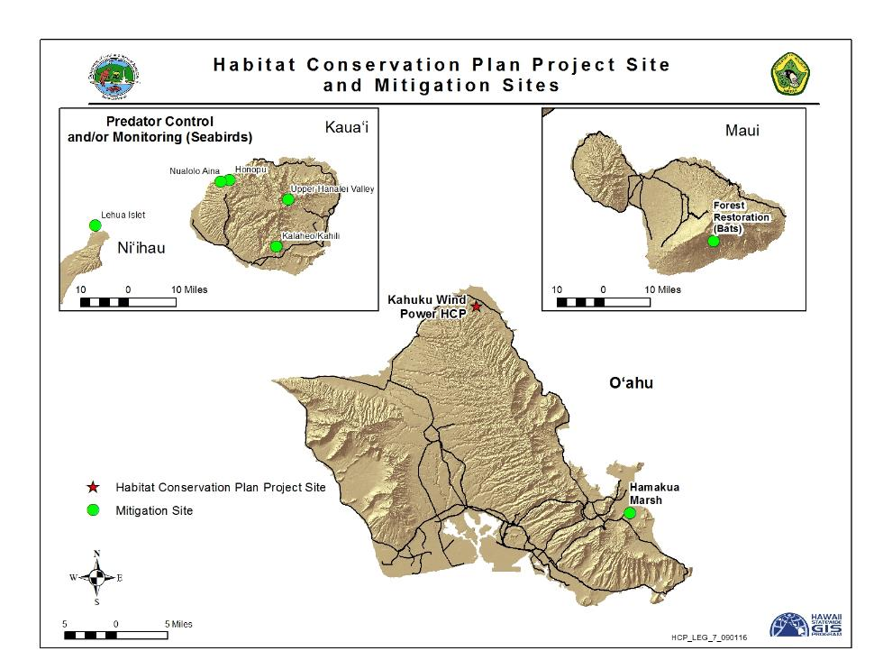
Figure 6. Location of Kahuku HCP and Mitigation Sites

Status of ITL: There were no fatalities of an HCP covered species at Kahuku Wind Power during FY 2020. There were no documented fatalities of species listed as threatened or endangered in Hawai‘i at the Kahuku Wind Power facility during the FY 2020 reporting period.

Table 11 provides an estimate of the overall total adjusted take that has occurred since Kahuku Wind ITL issuance.

Table 11. Total observed fatalities and estimated total take since ITL issuance under the Kahuku Wind Power ITL as of June 30, 2020.
Common Name | Total Observed Take | Estimated Unobserved Take¹ | Indirect Take using HCP multipliers | Total Estimated Take
Hawaiian Hoary Bat | 4 | 5 | 2 | 11
1 Based on the 80% credible maximum using the following model: Dalthorp, D., M. M. P. Huso, and D. Dail. 2017. Evidence of absence (v 2.0) software user guide: U.S. Geological Survey Data Series 1055.
In December 2014 the downed wildlife search area was reduced relative to previous years to a 35-meter radius plot centered on each turbine, and in April 2015 search frequency was increased from monthly to weekly. In FY 2020 all searches were performed by a canine-assisted team.

Mitigation Status:

Hawaiian Petrel & Newell’s Shearwater. In accordance with the Kahuku Wind HCP, the seabird mitigation plan for Newell’s Shearwater and Hawaiian Petrel requires the ITL holder to fund seabird colony-based protection and management measures on the island of Kaua‘i. Kahuku Wind also funded the Kaua‘i Endangered Seabird Recovery Project to deploy and then analyze data from Wildlife Acoustics SM2TM Song-meters at multiple locations in Kaua‘i’s remote mountains to survey for Newell’s Shearwater and Hawaiian Petrel nesting colonies. All seabird mitigation work was completed prior to FY 2020.

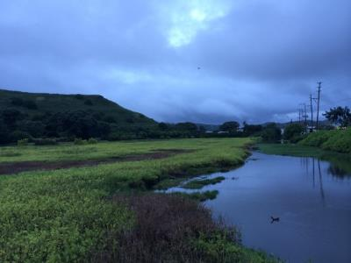
Hawaiian Stilt, Hawaiian Coot, Hawaiian Moorhen, and Hawaiian Duck. Baseline mitigation for the four waterbird species covered under the ITL consisted of payments to DOFAW to conduct predator control and wetland restoration at Hamakua Marsh, part of the State’s Kawainui-Hamakua Marsh Complex, for four years from FY 2012-2015. All waterbird mitigation work was completed prior to FY 2020.
‘Alae ‘Ula or Hawaiian Moorhen swimming at Hamakua Marsh

Hawaiian Hoary Bat. In accordance with the Kahuku Wind Power HCP, baseline bat mitigation consisted of a $150,000 payment to DOFAW (procured on May 31, 2012) for preserving or enhancing foraging and/or roosting habitat by constructing an ungulate-proof fence around a roughly 280-acre section of the State Kahikinui Forest Reserve and State Nakula Natural Area Reserve. In FY 2015, approximately 2,500 meters of fence were installed to enclose the unit. In FY 2020, Kahuku Wind Power, LLC began mitigation planning for the higher level of take and is considering funding Hawaiian Hoary Bat ecological research.

Pueo. Obligations for Pueo mitigation were complete prior to FY 2016. These included payments of $50,000 for Pueo research on O‘ahu aimed at determining population status and management priorities. With these and other funds DOFAW funded a Pueo research project in 2017 on O‘ahu, which was completed in FY 2018 and can be viewed at https://www.pueoproject.com. Funding of $25,000 was also provided to the Hawaii Wildlife Center prior to FY 2020.

Kawailoa Wind Power Habitat Conservation Plan, O‘ahu, Hawai‘i. Approved 2012.

ITL Licensee: Kawailoa Wind Power, LLC
Kawailoa Wind Power, O‘ahu
(Note that DESRI IV, LLC now owns Kawailoa Wind Power, LLC; it is an investment fund managed by D.E. Shaw Renewable Investments, LLC)

Project: Thirty WTGs with a total 69-MW energy generating capacity

ITL Duration: January 6, 2012 – January 6, 2032 (42% through the permit term as of the end of FY 2020)

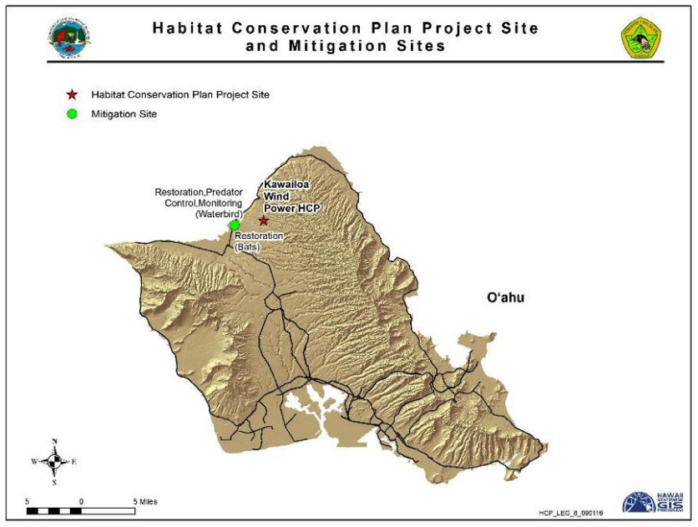
Figure 7. Location of Kawailoa HCP and Mitigation Sites

Take Authorization Over 20-year Term:

Table 12. Take Authorization for Kawailoa Wind HCP.
Common Name | Scientific Name | Level of Take¹ | 5-year Take Limit² | 20-year Take Limit
‘A‘o or Newell’s Shearwater | Puffinus auricularis newelli | Tier 1 | 3 adults/ juveniles & 2 chicks/eggs | 3 adults/ juveniles & 2 chicks/eggs
‘A‘o or Newell’s Shearwater | Puffinus auricularis newelli | Tier 2 | 6 adults/ juveniles & 3 chicks/eggs | 6 adults/ juveniles & 3 chicks/eggs
Koloa Maoli or Hawaiian Duck | Anas wyvilliana | Tier 1 | 4 adults/ juveniles & 4 ducklings | 4 adults/ juveniles & 4 ducklings
Koloa Maoli or Hawaiian Duck | Anas wyvilliana | Tier 2 | 6 adults/ juveniles & 6 ducklings | 6 adults/ juveniles & 6 ducklings
Ae‘o or Hawaiian Stilt | Himantopus mexicanus knudseni | Tier 1 | 6 adults/ juveniles & 3 fledglings | 8 adults/ juveniles & 4 fledglings
Ae‘o or Hawaiian Stilt | Himantopus mexicanus knudseni | Tier 2 | 8 adults/ juveniles & 4 fledglings | 12 adults/ juveniles & 6 fledglings
‘Alae Ke‘oke‘o or Hawaiian Coot | Fulica alai | Tier 1 | 6 adults/ juveniles & 3 fledglings | 8 adults/ juveniles & 4 fledglings
‘Alae Ke‘oke‘o or Hawaiian Coot | Fulica alai | Tier 2 | 8 adults/ juveniles & 4 fledglings | 12 adults/ juveniles & 6 fledglings
‘Alae ‘Ula or Hawaiian Moorhen | Gallinula chloropus sandvicensis | Tier 1 | 6 adults/ juveniles & 3 fledglings | 8 adults/ juveniles & 4 fledglings
‘Alae ‘Ula or Hawaiian Moorhen | Gallinula chloropus sandvicensis | Tier 2 | 8 adults/ juveniles & 4 fledglings | 8 adults/ juveniles & 4 fledglings
‘Ōpe‘ape‘a or Hawaiian Hoary Bat3 | Lasiurus cinereus semotus | Tier 1 | 20 individuals | 20 individuals
‘Ōpe‘ape‘a or Hawaiian Hoary Bat3 | Lasiurus cinereus semotus | Tier 2 | 40 individuals | 40 individuals
‘Ōpe‘ape‘a or Hawaiian Hoary Bat3 | Lasiurus cinereus semotus | Tier 3 | 60 individuals | 60 individuals
Pueo or Hawaiian Owl | Asio flammeus sandwichensis | Tier 1 | 4 adults & 4 owlets | 4 adults & 4 owlets
Pueo or Hawaiian Owl | Asio flammeus sandwichensis | Tier 2 | 6 adults & 6 owlets | 6 adults & 6 owlets
¹ Take authorization is delineated by Baseline and Higher Limits (Tiers). Upon reaching Higher Limits additional mitigation measures or funding are triggered to ensure that mitigation keeps pace with take.
² Exceeding the 5-year Take Limit (including observed and unobserved take) will require one or more of the following: adaptive management, increased mitigation, or a major ITL amendment.
3 Minor amendment to clarify permitted bat take processed on November 26, 2014.

Status of ITL: There was no take of covered species at the Kawailoa Wind Power facility during FY 2020.
Table 13 provides an estimate of the overall total adjusted take that has occurred since Kawailoa Wind ITL issuance.
Table 13. Total observed fatalities and estimated total take since ITL issuance under the Kawailoa Wind Power ITL as of June 30, 2020.
Common Name | Total Observed Take¹ | Estimated Unobserved Take² | Indirect Take using HCP multipliers | Total Estimated Take
Hawaiian Hoary Bat | 38 | 47 | 9 | 94
Hawaiian Petrel | 2 | ND | ND | ND
1 Excludes hoary bat takes that were incidental and not observed during systematic monitoring (incidental takes are evaluated as part of the EoA modeling software and therefore accounted for in the unobserved take).
2 Based on the 80% credible maximum using the following model: Dalthorp, D., M. M. P. Huso, and D. Dail. 2017. Evidence of absence (v 2.0) software user guide: U.S. Geological Survey Data Series 1055.
ND - Not determined.
With completion of three years of intensive monitoring in November 2015 and concurrence from the USFWS and DOFAW, fatality-monitoring plots were reduced in size on November 1, 2015 to 35 meter radius circular plots. These plots are centered on the wind turbine generators (WTGs) and searched twice per week. In FY 2020 100% of fatality searches were performed by a canine-assisted team.
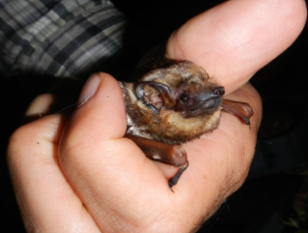
The total estimated take of 94 bats (with 80% statistical certainty and indirect take) exceeds the total permitted take for bats. Kawailoa submitted an application and amended HCP to the agencies for review and approval in FY 2019. The amendment decision had not been made as of the end of FY 2020 because a contested case was initiated subsequent to the BLNR approval.
Female Hawaiian Hoary Bat caught at ´U´koa Wetland, Oahu.
To minimize Hawaiian Hoary Bat take, in FY 2019 Kawailoa Wind reduced the number of turbine stop/start events per night by extending the rolling average time used from 10 to 20 minutes. However, the 20-minute rolling average resulted in unanticipated wind turbine behavior and the project returned to a 10-minute rolling average in FY 2020. Kawailoa Wind is working on a solution in order to return to a 20-minute rolling average. Additionally, the project installed acoustic deterrents at all 30 project turbines in May and June 2019.
Mitigation Status:
Newell’s Shearwater. Tier 1 mitigation for Newell’s Shearwater as described in the HCP consisted of (1) providing funding for adapting a resetting trap for use in Hawai‘i, (2) field testing traps at a suitable location where predators are known to occur, and (3) supporting a one-year pilot study to provide localized predator control in an area where Newell’s Shearwater are known to be breeding. Item number three was completed for a project on Kaua‘i. Projects that fulfilled these obligations were completed by end of FY 2015.
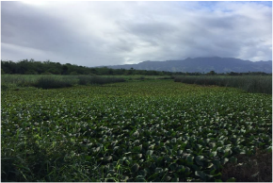
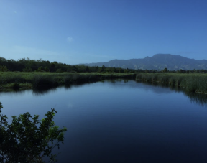
Hawaiian Duck, Hawaiian Stilt, Hawaiian Moorhen, & Hawaiian Coot. The ‘Uko‘a Wetland mitigation program for Tier 1 mitigation continued for waterbirds. In FY 2020, activities associated with Tier 1 included invasive vegetation removal, predator control, monitoring predator presence, and fence monitoring and maintenance. In FY 2020, a total of 203 predators were removed from ‘Uko‘a Wetland including 7 pigs, 168 mongooses, three cats, and 25 rats. A total of 40 weekly waterbird surveys were completed in FY 2020 at ‘Uko‘a Wetland at 8 stations. An additional Point Count (PC) station was added in May 2020 in an area where Hawaiian Moorhens were newly observed. In addition, an aerial drone survey was conducted in June 2020 to identify more potential PC locations. The Hawaiian Moorhen was the listed waterbird species most frequently detected during surveys. In FY 2020, Hawaiian Moorhens were recorded at all PC stations except PC 2, and either adults or chicks were observed or heard on 37 out of 40 survey dates. Hawaiian Moorhen breeding activity was observed on three occasions but no chicks are believed to have successfully fledged. No Hawaiian Coots were seen in FY 2020. Five detections of adult Hawaiian Stilts were made on three survey dates in FY 2020.
Water hyacinth within removal area before removal work was initiated (Top), and after removal was complete (Bottom).

Hawaiian Hoary Bat. In FY 2020, activities associated with Tier 1 mitigation included invasive vegetation removal, bat lane maintenance, and bat acoustic monitoring. A total of 16 bat lanes within ten zones were cleared in previous years throughout ‘Uko‘a Wetland. Bat lane maintenance occurred in Q4 of FY 2020 and consisted of cutting branches and trees that regrow within the 5-meter wide bat lanes. Hawaiian Hoary Bats were detected on 680 of 3,344 detector-nights (20.3% of detector nights) at ‘Uko‘a in FY 2020. This represents a slight increase from FY 2019, which documented detections on 13.8% of detector-nights. Bat activity appears to have increased at ‘Uko‘a Wetland since sampling began in 2012. Detection of feeding buzzes also increased after the mitigation.
Kawailoa Wind has contracted three studies as Tier 2/3 bat mitigation. The results of one USGS research project were published in an article titled “Multi-state occupancy models of foraging habitat use by the Hawaiian hoary bat (Lasiurus cinereus semotus)” in the Journal PLoS ONE in October 2018. The primary findings reported by Gorresen et al. (2018) include: 1) elevated levels of acoustic activity by Hawaiian Hoary Bats were found to be related primarily to beetle biomass, and 2) video-derived observations demonstrated higher and more accurate estimates of the prevalence of high bat flight activity and feeding events than acoustic sampling methods. The objectives of the USGS Hawaiian Hoary Bat Conservation Genetics study are to improve the understanding of the genetic diversity of the Hawaiian Hoary Bat, identify bat prey items, and identify the sex of bat carcasses and any sex-specific food habits. A technical report was published for this study in November 2018. During FY 2019, this research determined the sex of 88 Hawaiian Hoary Bat tissue samples using genotyping, which allows for more reliable evaluation of the ratio of males to females affected by collisions with wind turbines. The results indicate that 65% of observed fatalities at the sampled wind farms have been male. The third study, conducted by Western EcoSystems Technology Inc., is a multi-year Hawaiian Hoary Bat acoustic surveys study to examine the distribution and seasonal occupancy of the Hawaiian Hoary Bat on O‘ahu. The Year 2 Status Report for the study (covering results from June 8, 2017 to October 7, 2019) indicated highest detection frequencies in the northern Koʻolau Mountains and the highest elevation areas of the Waiʻanae Mountains.
Funding the above-listed Tier 2/3 studies left an outstanding obligation of $353,702 for Tier 3 bat mitigation. To fulfill the remaining uncommitted funding obligation, Kawailoa Wind contributed the remaining funds towards the purchase of the 3,716-acre Waimea Native Forest, an acquisition through a partnership that includes The Trust for Public Land and others. The acquisition was completed in December 2019.
Pueo. A contribution of $12,500 was made to the Hawai‘i Wildlife Center for Pueo rehabilitation in FY 2012. An additional $12,500 was provided to DOFAW to complete the mitigation obligation in the second quarter of FY 2017. With these and other funds DOFAW funded a Pueo research project in 2017 on O‘ahu which was completed in FY 2018 and can be viewed at https://www.pueoproject.com.

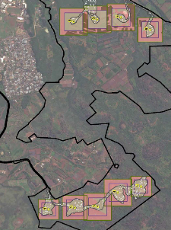
Nā Pua Makani Wind Energy Project Habitat Conservation Plan, O‘ahu, Hawai‘i. Approved 2019.
Nā Pua Makani Wind Energy Project, O‘ahu

ITL Licensee: Nā Pua Makani Power Partners, LLC
(Note that AES Corporation owns Nā Pua Makani Power Partners, LLC)

Project: Eight WTGs with a total 24-MW energy generating capacity

ITL Duration: April 30, 2019 – April 30, 2040 (5% through the permit term as of the end of FY 2020)

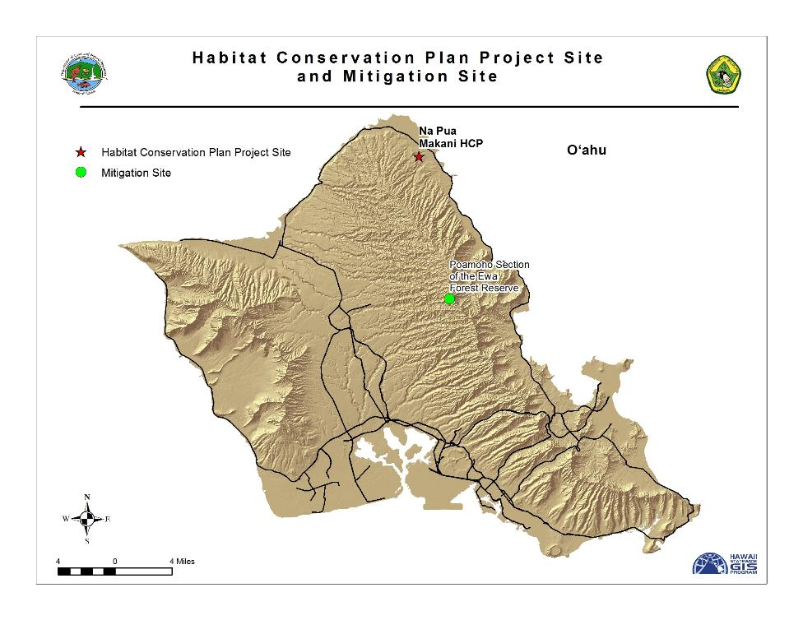
Figure 8. Location of Nā Pua Makani HCP and Mitigation Site
Take Authorization Over 21-year Term:

Table 14. Take Authorization for Nā Pua Makani Wind Energy Project HCP.
Common Name | Scientific Name | Level of Take | 21-year Take Limit
‘Ōpe‘ape‘a or Hawaiian Hoary Bat | Lasiurus cinereus semotus | Tier 1 | 34 bats
‘Ōpe‘ape‘a or Hawaiian Hoary Bat | Lasiurus cinereus semotus | Tier 2 | 51 bats
‘A‘o or Newell’s Shearwater | Puffinus newelli | Length of permit | 4 adults/immatures and fledglings & 2 chicks/eggs
Nēnē or Hawaiian Goose | Branta sandvicensis | Length of permit | 6 birds
Koloa Maoli or Hawaiian Duck | Anas wyvilliana | Length of permit | 4 birds
Ae‘o or Hawaiian Stilt | Himantopus mexicanus knudseni | Length of permit | 4 birds
‘Alaeke‘oke‘o or Hawaiian Coot | Fulica alai | Length of permit | 8 birds
‘Alae ‘ula or Hawaiian Moorhen | Gallinula chloropus sandvicensis | Length of permit | 8 birds
Pueo or Hawaiian Short-eared Owl | Asio flammeus sandwichensis | Length of permit | 4 adults/fledged young & 4 chicks/eggs
Status of ITL: In FY 2019 the Project began construction, which continued throughout FY 2020. The project is expected to begin commercial operations in FY 2021. Turbines at the site were not fully operational in this fiscal year. There was no reported take of covered species at the Nā Pua Makani Wind Energy facility during FY 2020 but there was a downed wedge-tailed shearwater (a species that is not threatened or endangered) that was found alive near a turbine and released the following day.
Mitigation Status:
Planning for mitigation actions for the covered species began in FY 2020 in anticipation of commercial operations in FY 2021.

Transportation Projects

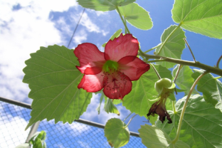
Relocation of Abutilon menziesii Habitat Conservation Plan, Kapolei, O‘ahu. Approved 2004.
Ko‘oloa‘ula (Abutilon menziesii), Island of O‘ahu.

ITL Licensee: Hawai‘i Department of Transportation

Project: Development of 1,381-acre East Kapolei Master Plan project and construction of the North-South Road arterial highway bisecting the property

ITL Duration: March 18, 2005 – July 31, 2021 (93.8% through the permit term as of the end of FY 2020)

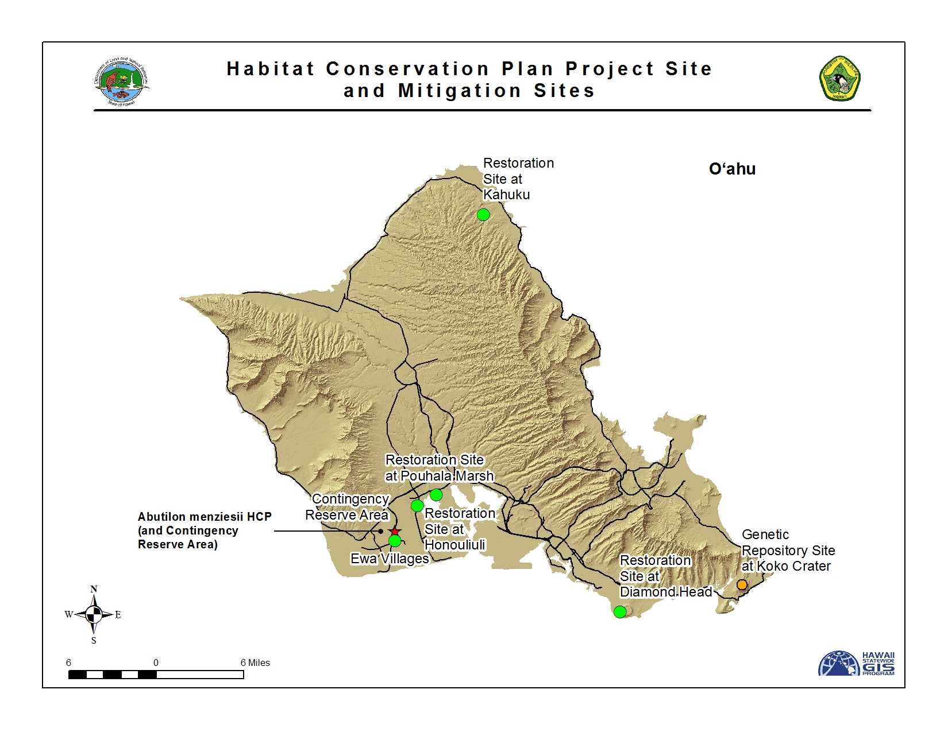
Figure 9. Location of Abutilon HCP and Mitigation Sites

Take Authorization:

Table 15. Take Authorization for Abutilon HCP.
Common Name | Scientific Name | Total Authorized Over ITL Duration
Ko‘oloa‘ula | Abutilon menziesii | All individual plants within the 1,381-acre project area

Status of ITL: All plants have been moved during the early years of the HCP. Five mitigation sites have been established and a genetic repository location contains plants with genetic representation of the translocated plants. A Contingency Reserve Area was established per the requirement in the HCP, with additional plantings, to remain until short-term success criteria has been confirmed at a minimum of one of the three mitigation sites. Achieving the short-term success criteria has not been clearly demonstrated at any site.

Mitigation Status:

The goal of the HCP, as stated, is to initiate and sustain a program that will result in an overall net gain in the number of endangered Abutilon menziesii plants on O‘ahu. The end goal is the establishment of three wild sites that are protected, self-sustaining populations of A. menziesii from the single degraded Kapolei population. Wild populations of A. menziesii have been established at the following sites: 1) Diamond Head State Park; 2) Honouliuli Refuge, part of the U.S. Fish and Wildlife Service’s O‘ahu National Wildlife Refuge Complex; and 3) Pouhala Marsh on City and County property in Waipahu. Three new sites were established in FY 2018 in the attempt to bring this species’ conservation efforts into current DOFAW projects with long-term project investment by the DOFAW O‘ahu Branch. They are: Hamakua Marsh in Kailua, Makua Keaʻau Forest Reserve in western O‘ahu, and a Waiʻanae Mountains Watershed Partnership restoration site in Waiʻanae Kai. The species is being incorporated within these already established efforts to help ensure long-term progress at little to no added cost of expansion and maintenance efforts. Additionally, some outplanting occurred in the past at the ʻEwa Villages Golf Course which has successfully maintained 39 individuals, although due to irrigation it is not considered a wild site. The main genetic reserve site established at Koko Crater Botanical Garden currently has 139 mature (reproductive) plants (63% genetic representation).

Until there is assurance that success criteria are met there is also maintained a Contingency Reserve Area within the 1,381 acre project area. In FY 2020 the Contingency Reserve Area population had 29 individual plants, a decline from 35 mature A. menziesii plants present in FY 2019, and 68 mature plants in FY 2018. Information incorporated in the reporting changed in FY 2020 and is reflected in population metrics compared to previous year’s reports; however, no significant changes in the populations were observed in the reporting period. From an original founder population of 133 plants on the project site in 2002, outplanting efforts have resulted in 107 founders genetically represented at all the sites. In total, 628 mature A. menziesii plants are present across all of the HCP populations at the targeted wild sites, the genetic reserve sites, and the Contingency Reserve Area. No new plants were outplanted during the reporting period.

In FY 2020, DOFAW completed a full monitoring survey of all the management sites. This monitoring data showed that the long term criteria has not been met and additional management is required. The main reason for the lack of seedling recruitment and survivorship may be a lack of sufficient moisture on a regular basis, which may be due to a variety of factors. However, the expansion of populations via clonal growth (such as rooting of the overhanging branches) has been observed and may warrant a revision to the measures of success in the HCP.

Funding Source and Status: Funding to implement mitigation activities was provided to DOFAW from the Hawai‘i Department of Transportation and were exhausted in January 2020. DOFAW committed to managing the project through the remaining ITL term, and during FY 2020 continued to seek discussions with the license-holder on achieving the HCP’s success criteria.

Other Development Projects

Cyanotech Aquaculture Facility Habitat Conservation Plan, Keahole Point, Hawai‘i. Approved 2003.

ITL Licensee: Cyanotech Corporation

Project: Commercial microalgae farming operation

ITL Duration: Original Endangered Species Permit: April 2002 (short term); Subsequent ITL December 24, 2003 – March 17, 2016; Renewal application for 2016-2035 in process
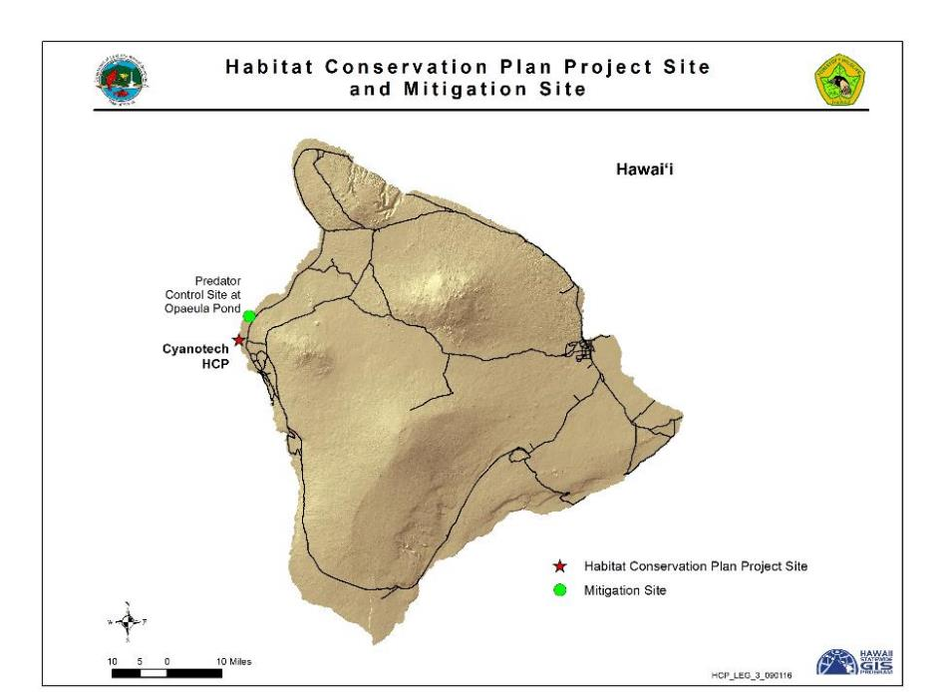
Figure 10. Location of Cyanotech HCP

Take Authorization Over 13-year Term:

Table 17. Take Authorization for Cyanotech HCP.
Permit Period | Common Name | Scientific Name | Total Authorized Over ITL Duration
2002-2016 | Ae‘o or Hawaiian Stilt | Himantopus mexicanus knudseni | The greater of, 45, or the number of chicks produced to offset losses
2016-2035*  (requested renewal) | Ae‘o or Hawaiian Stilt | Himantopus mexicanus knudseni | 38 (requested)
*not yet approved

Status of ITL: There were no reported fatalities of an HCP covered species at Cyanotech during FY 2020. There were no documented fatalities of any other species listed as threatened or endangered in Hawai‘i at the Cyanotech facility during the FY 2020 reporting period.
In accordance with the Cyanotech HCP, surveys for incidental take are conducted once per week during the nesting season (March-August) and once per month during the non-nesting season (September-February). Monitoring for injured wildlife is conducted daily as part of normal operations of the production raceways. Monitoring documented two Hawaiian Stilt nests with four eggs in each nest. One nest was flooded and abandoned after a heavy rain event. The second nest successfully produced two fledglings.

Table 18 provides an estimate of the overall total adjusted take that has occurred since Cyanotech ITL issuance.

Table 18. Total observed fatalities since ITL issuance and estimated total adjusted take covered under the Cyanotech ITL as of June 30, 2016.
Common Name | Total Observed Take | Total Adjusted Take1
Hawaiian Stilt | 18 adults, 4 chicks | 43 fledglings
¹ Total adjusted take represented as number of fledglings, based on the survival rate of 2.17 fledglings with respect to incidental take of adult as described in the 2006 Cyanotech Amendment.
Mitigation Status:
Hawaiian Stilt. Prior to the HCP, mitigation occurred onsite at a lake that was managed as nesting and foraging habitat for stilts. Concerns about the proximity to the airport led to the onsite mitigation site being closed in 2002, with hazing implemented to discourage further nesting. Prior to being shut down, the on-site lake resulted in 237 fledglings. 48 of those fledged in 2002 and were “credited” to the HCP for the first year of permit coverage. According to a 2006 minor amendment, Cyanotech mitigation was to be satisfied by funding and implementing predator control at an off-site location. ‘Ōpae‘ula (now Kapo‘ikai) pond is a 3.24 hectare coastal wetland located in the North Kona district of Hawai‘i Island and was identified as a viable location for predator control efforts. Cyanotech worked with the private landowner to fund predator control efforts at ‘Ōpae‘ula pond to meet mitigation obligations to satisfy the HCP.

Renewal: In June 2016, Cyanotech requested a renewal for the ITL and HCP, with a requested take of 38 Hawaiian Stilts for the next 19 years (2016-2035). Cyanotech is required to propose a suitable potential mitigation project within one year of approval. Cyanotech is working on an agreement with the County of Hawaii to provide predator control at the Kealakehe Wastewater Treatment Plant as part of their off-site mitigation.

Kaua‘i Lagoons (Hōkūala) Habitat Conservation Plan, Kaua‘i, Hawai‘i. Approved 2012.

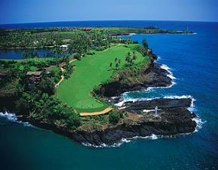
ITL Licensee: Kaua‘i Lagoons, LLC
Kaua‘i Lagoons, Kaua‘i.
(Note that Tower Kaua‘i Lagoons, LLC is the current name of the entity holding the license)

Project: Oceanfront resort encompassing approximately 600 acres

ITL Duration: April 11, 2012 – April 11, 2042 (27% through the permit term as of the end of FY 2020)

Take Authorization Over 30-year Term:

Table 19. Take Authorization for Kaua‘i Lagoons HCP.
Common Name | Scientific Name | Type of Take | Total Authorized Over ITL Duration
‘A‘o or Newell’s Shearwater | Puffinus auricularis newelli | Life of permit | 29ª
Koloa Maoli or Hawaiian Duck | Anas wyvilliana | Mortality or Non-Lethal | 36
Ae‘o or Hawaiian Stilt | Himantopus mexicanus knudseni | Mortality or Non-Lethal | 38
‘Alae Ke‘oke‘o or Hawaiian Coot | Fulica alai | Mortality | 110
‘Alae Ke‘oke‘o or Hawaiian Coot | Fulica alai | Non-Lethal | 180
‘Alae ‘Ula or Hawaiian Moorhen | Gallinula chloropus sandvicensis | Mortality | 40
‘Alae ‘Ula or Hawaiian Moorhen | Gallinula chloropus sandvicensis | Non-Lethal | 30
Nēnē or Hawaiian Goose | Branta sandvicensis | Mortality or Non-Lethal | 17
‘Ua‘u or Hawaiian Petrel | Pterodroma sandwichensis | Life of Permit | 1
‘Akē‘akē or Band-rumped Storm Petrel | Oceanodroma castro | Life of Permit | 1
ª Authorized level of take changed from 27 to 29 as processed under the September 2013 minor amendment.

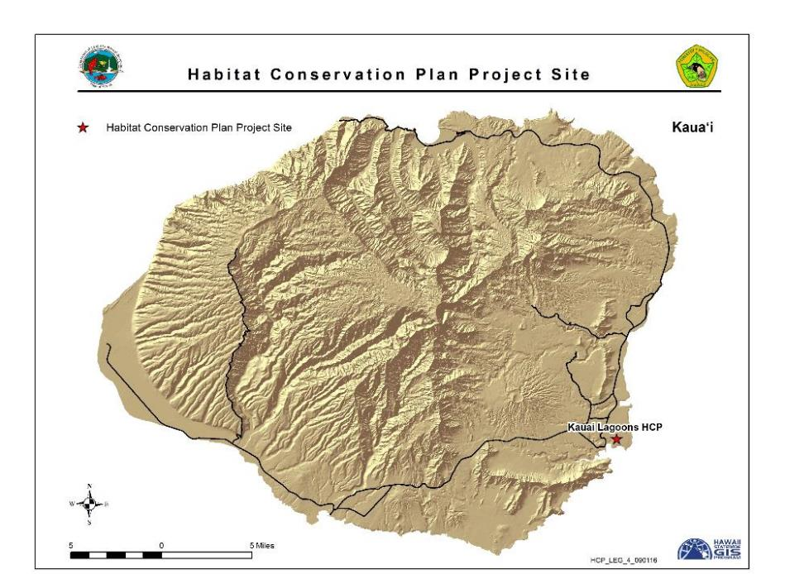
Figure 11. Location of Kaua‘i Lagoons HCP

Status of ITL: Table 20 provides a listing of all documented incidental take during the reporting period.
Table 20. Documented incidental take of Covered Species at the Kaua‘i Lagoons site during the reporting period.
Common Name | FY 2020 Fatalities
Hawaiian Moorhen | 2
Hawaiian Coot | 1
Table 21 provides the observed mortalities that have occurred since Kaua‘i Lagoons ITL issuance. Of concern is the rate of Hawaiian Moorhen take. Although only 27% of the license term is complete, 70% of the permitted Hawaiian Moorhen lethal take has been reached as of the end of FY 2020.

Table 21. Total observed incidental take since ITL issuance under the Kaua‘i Lagoons ITL as of June 30, 2020.
Common Name | Total Observed Take | Total Including Indirect Take
Newell’s Shearwater | 7 | 7
Nēnē | 3 | 5
Hawaiian Moorhen | 20 | 28
Hawaiian Duck | 5 | 7
Hawaiian Stilt | 0 | 0
Hawaiian Coot | 17 | 20
In accordance with the Kaua‘i Lagoons HCP, the Kaua‘i Lagoons Resort (Resort) continued to implement the following minimization measures during this reporting period:
- On-site predator control;
- Comprehensive endangered species awareness training to all Resort employees, with updated modules, and retraining for all staff and contractors after the new owners took over;
- Deployment of construction monitors and biological monitors during construction operations to prevent harm to ITL covered species;
- Education program to inform golfers of the presence of endangered species and implement measures to avoid harm to such species while golfing;
- Program to minimize light-induced attraction of seabirds to Resort facilities by installing appropriate lighting fixtures, and implementing appropriate seasonal restrictions and practices; and
- Maintenance of on-site nesting areas.

The total number of Nēnē nests documented at Kaua‘i Lagoons during FY 2020 was 15, from 15 different pairs and which produced 23 fledglings. On June 24, 2019 the U.S. Department of Agriculture Wildlife Services on behalf of Hawai‘i Department of Transportation, Airports Division, began a pilot project to haze Nēnē from the property due to proximity to the airport using dogs and other non-lethal methods, which extended throughout the reporting period and greatly reduced the number of Nēnē present on site. Other covered species also nested in FY 2020 including four Hawaiian Coot nests producing eight chicks, 15 Hawaiian Duck nests producing 39 chicks, and 30 Hawaiian Moorhen nests producing 27 chicks (not all chicks will fledge).

The average number of individuals of each species observed during 91 waterbird counts was as follows: Nēnē, 19; Hawaiian Duck, 16; Hawaiian Moorhen, 53; Hawaiian Coot, 97; and Hawaiian Stilt, four.

In FY 2020, the ITL-holder submitted an HCP amendment request to reflect the property’s current name, implementing entity, and financial assurances. The request is currently under review by the agencies.

Mitigation Status:
Nēnē, Hawaiian Stilt, Hawaiian Coot, Hawaiian Moorhen, & Hawaiian Duck. Baseline mitigation for waterbirds consists of providing and maintaining approximately 35 acres of lagoons on the property that are an important habitat for endangered waterbird species, including predator control trapping and wildlife monitoring. Predator control efforts during this reporting period included deploying up to 63 live traps on the property. Live traps were deployed throughout the year and were placed in areas in response to sightings of mammalian predators, and checked daily.
Trapping resulted in the removal of 41 cats, 25 pigs, and one dog. Additionally, 1,799 chickens were removed using air rifles. Kaua‘i Lagoons also contributed mitigation funding of $85,000 to DOFAW in May 2012 to be used to conduct predator control and/or manage Nēnē at a translocation site(s) after the completion of the State’s five-year translocation project ending in 2016.
Newell’s Shearwater, Hawaiian Petrel, & Band-rumped Storm Petrel. The minor amendment in 2013 increasing Newell’s Shearwater take specified contribution of mitigation funding for seabird take in the amount of $10,000 annually to the National Fish and Wildlife Foundation (NFWF) account, to be held until such time as a Kaua‘i island wide seabird HCP was finalized and approved. On July 9, 2019, $10,000 was provided to NFWF to cover the 2019-2020 season. In FY 2020, the Kaua‘i Seabird HCP was approved.

Relocation of Round-leaved Chaff Flower (Achyranthes splendens var. rotundata) Habitat Conservation Plan, Kenai Industrial Park, Kapolei, O‘ahu, Hawai‘i. Approved 2014
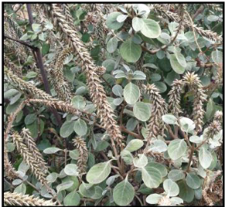
Achyranthes splendens var. rotundata.
ITL Licensee: CIRI Land Development Company (In September 2014 CIRI Land Development Company sold the property under the ITL to AKC Leasing Corporation)

Project: Industrial development on a 0.75-acre parcel

ITL Duration: February 10, 2014 – February 9, 2024 (63% through the permit term as of end of FY 2020)

Take Authorization Over 10-year Term:

Table 22. Take Authorization for Kenai Industrial Park.
Common Name | Scientific Name | Total Authorized Over ITL Duration
Round-leaved Chaff Flower | Achyranthes splendens var. rotundata | 3 individuals and their seed bank

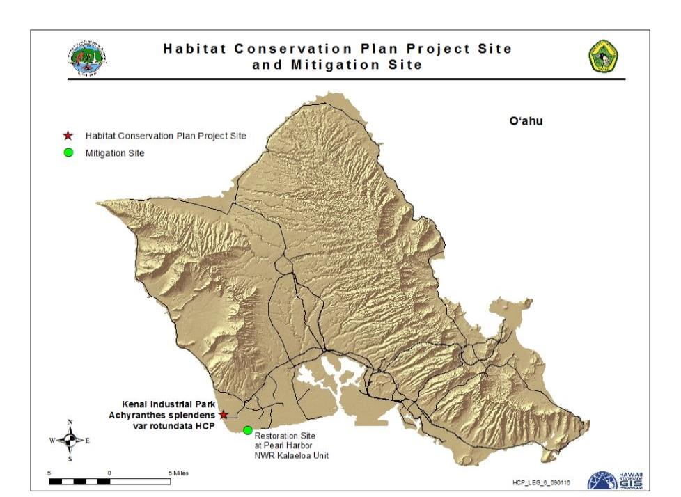
Figure 12. Location of Kenai Industrial Park HCP

Status of ITL: All plants at the site have been removed under supervision of the State Botanist. Approximately 23,000 seeds were collected in 2014. Approximately 400 of the seeds collected were used to germinate plants at Hui Ku Maoli Ola native plant nursery, the remainder are in storage at the Lyon Arboretum seed facilities. The seeds at Hui Ku Maoli Ola were propagated and were used for out-planting at the mitigation site.
Mitigation Status:
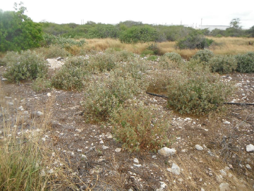
Round-leaved Chaff Flower. In accordance with the HCP, seeds were collected from the project site and were either stored or propagated for future out-planting at the mitigation site located at the Kalaeloa Unit of the Pearl Harbor National Wildlife Refuge.
A total of 159 plants were installed in four plots within the Kalaeloa Unit in November and December 2014. Each planting plot is approximately 12 × 12 meters (39.5 × 39.5 feet). In addition, four individual plants of Round-leaved Chaff Flower were planted outside of the Plots 1–4 in November 2014 and this area was designated Plot 5. As of May 6, 2020, there were 13 outplants (8% of 159 planted) surviving; therefore, the 75% survival by Year 5 criteria (success criterion #1) in the HCP has not been met. In all, 21 seedlings reached at least six inches in height in FY 2020, bringing the total number of progeny for the project to 119. In addition, one individual plant previously thought dead has been rediscovered. Success criteria that apply to Year 5 of the monitoring include no fewer than 120 plants surviving, no mature kiawe present within the plots, less than 25% cover of herbaceous non-native plants, and more than 25% cover of native plants. At the end of FY 2020, there were 110 plants surviving, native plant cover ranged from 17-50% in the plots, and non-native plant cover ranged from 8-67% in the plots. The license-holder reports that weeding will take place to ensure all plots meet other success criteria.
Plot 1 outplants on 4/25/17
As noted above, a problem meeting success criterion # 1 of the HCP (survivorship of initial outplants) has been an issue of concern in the past several years. The ITL licensee’s consultant and DOFAW discussed removing this success criterion which the consultant indicated they believed was due to incorrect assumptions about the lifespan of the species. DOFAW’s State Botanist did not agree with this point but did indicate that the State’s experience in other projects is that the species typically does not achieve the survivorship levels in this HCPs specified success criterion #1. The issue was brought to the ESRC in the past and removal of this criterion was approved. After additional subsequent discussions on the process of removal, a formal decision to remove it via a notification letter to the licensee is planned in FY 2021.

Funding Status: In September of 2014, CIRI Land Development Company (original owner of the property under the ITL) sold the property to AKC Leasing Corporation. AKC Leasing Corporation acknowledged that ownership of the property is subject to conditions under the approved Incidental Take License Number ITL-18 and the associated HCP for Kenai Industrial Park. AKC Leasing Corporation is required to provide all funding necessary to fulfill obligations outlined in the approved HCP including funding assurances. In FY 2020, AKC Leasing Corporation used their own procurement processes to fulfill HCP obligations.

Kaua‘i Seabird Habitat Conservation Plan, Kaua‘i Island, Hawai‘i. Approved 2020.

ITL Licensees:
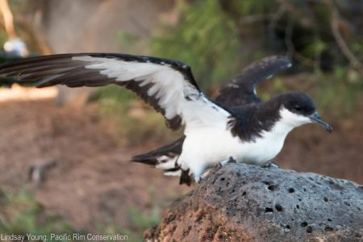
- Alexander & Baldwin, Inc.
Newell’s Shearwater (Puffinus auriculari
- County of Kaua‘i
- Hawai‘i Department of Transportation
- Kaua‘i Marriott Resort (Essex House Condominium Corporation)
- Kaua‘i Coffee Company, LLC
- NCL (Bahamas) Ltd.
- Princeville Resort Kaua‘i (XI Kaua‘i PV Hotel)
- Sheraton Kauai (Kauai Blue, Inc)

Project: Island wide conservation plan to address the impacts of artificial lights to seabirds on Kaua‘i

ITL Duration: June 12, 2020 – June 12, 2050

Take Authorization Over 30-year Term:

Table 23. Take Authorization Over the Permit Term for All Participating Entities.
Participant | Fledglings (lethal/non-lethal)
Participant | Newell’s Shearwater (‘A‘o) | Hawaiian Petrel (‘Ua‘u) | Band-rumped Storm Petrel (‘Akē‘akē) | Green Sea Turtle (Honu)
Kaua‘i Marriott Resort | 33/22 | 1/1 | 1/1 | 0
Kaua‘i Coffee | 34/27 | 0 | 0 | 0
Sheraton Kaua‘i | 81/64 | 1/1 | 3/3 | 0
NCL | 30/30 | 6/6 | 6/6 | 0
Princeville Resort | 125/476 | 6/6 | 1/1 | 0
County of Kaua‘i | 276/217 | 17/4 | 4/0 | 0
Hawai‘i Dept. of Transportation | 103/144 | 5/12 | 1/2 | 0
Alexander & Baldwin | 104/80 | 3/3 | 1/1 | 0

Status of ITL: The Kaua‘i Seabird Habitat Conservation Plan (KSHCP) was approved in FY 2020 and addresses artificial nighttime lighting threats and light attraction on covered seabirds and the Hawaiian Green Sea Turtle.

A Honu nest was observed at the Sheraton beach in June 2020. There was no take of HCP covered species during the reporting period.

Mitigation Status:

Hawaiian Petrel, Newell’s Shearwater & Band-rumped Storm Petrel. Under the KSHCP, the participants will mitigate their take, in part, by enhancing, protecting, and managing suitable seabird breeding habitat on Kaua‘i to facilitate successful production of covered seabirds. This will be accomplished through: the construction and maintenance of a predator proof enclosure installation; long-term maintenance of social attraction equipment within the enclosure; and eradication of predators from within the enclosure, and implementation of long-term predator control at the site. The KSHCP identified the Kahuama‘a Flats within the Kōke‘e State Park as a suitable location for the mitigation/social attraction site. Planning and permitting is currently in progress with construction expected to be completed in the upcoming fiscal year.

SUMMARY OF SAFE HARBOR AGREEMENTS AND ASSOCIATED INCIDENTAL TAKE LICENSES

Safe Harbor Agreement for Puʻu o Hōkū Ranch, Molokaʻi.

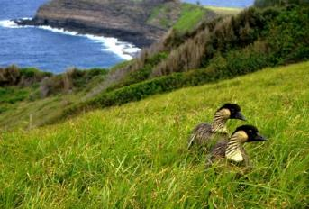
ITL Licensee: Puʻu o Hōkū Ranch, Limited.
Nēnē, official bird of the State of Hawai‘i, resting in the foreground.

Project: Reintroduce Nēnē (Branta sandvicensis) to Puʻu o Hōkū Ranch, Moloka‘i.
ITL and SHA Duration: ITL has no specific expiration and is valid unless rescinded; SHA period was from September 4, 2001 to September 3, 2008 (DOFAW is currently in discussion with Pu‘u o Hōkū Ranch to enter into a new agreement).

Take Authorization: Incidental take of Nēnē on lands owned or otherwise controlled by Puʻu o Hōkū Ranch, Limited.

Baseline Condition: At the time of agreement execution, there was no wild Nēnē on Moloka‘i. Therefore the baseline condition is zero wild Nēnē on Puʻu o Hōkū Ranch property. The SHA allowed for reintroduction of Nēnē on Puʻu o Hōkū Ranch property, construction of a release pen, provision of habitat for Nēnē grazing and breeding, and control of predators in the release pen and breeding areas.

Status of ITL and SHA: There was no take of Nēnē at Pu‘u o Hōkū Ranch in FY 2020.. Nēnē monitoring was performed on a weekly basis by DOFAW personnel throughout the reporting period. Observations from surveys throughout the reporting period resulted in a total of 23 birds, the estimated population size, of which 22 were identified by their State and Federal bands. One bird did not have a band. A one-day annual Nēnē survey throughout Molokai was conducted on September 19, 2019 during which a total of 12 banded birds were observed.

During the August – April nesting season two nests were recorded within the open-top release pen at Pu‘u o Hōkū Ranch and no additional nests were located on the ranch or adjacent areas. One nest successfully produced one fledgling which was banded. The second nest was unsuccessful due to mongoose predation on the eggs. No birds died at the pen this year.

Maintenance at the three-acre open-top release pen included monthly checks and repairs of fences, weekly checks of waterlines and water troughs, and mowing the half-acre around the pen. In addition, 40 feet of electric fence line was replaced in this reporting period. Alien vegetation (Lantana and Haole Koa) was removed from the pen. Mowing by DOFAW staff totaled 30 acres. Ranch personnel mowed an additional 800 acres within the ranch.

Sixteen live traps were checked regularly at the pen and a total of 44 mongooses were removed around the open-top release pen at Puʻu o Hōkū Ranch in FY 2020.

A total of 74 birds were translocated to the Puʻu o Hōkū Ranch from 2002-2005. Table 1 provides survey data for the original 74 birds translocated to the Puʻu o Hōkū Ranch. The percentage of the original 74 birds that were re-sighted is a factor of survey effort and does not account for any unknown mortality or emigration from the ranch, and may not necessarily be a measure of translocation success.

Table 1. Observations of Nēnē translocated to Puʻu o Hōkū Ranch
Year | No. of Birds Translocated | Total Birds Translocated | No. of Known Fatalities | No. of Birds Sighted | Percentage (%) of Translocated Birds Sighted (excluding known fatalities)
2020 | 0 | 74 | 0 | 0 | 0
2019 | 0 | 74 | 0 | 1 | 2
2018 | 0 | 74 | 0 | 1 | 2
2017 | 0 | 74 | 0 | 1 | 2
2016 | 0 | 74 | 0 | 2 | 3
2015 | 0 | 74 | 0 | 4 | 5
2014 | 0 | 74 | 0 | 6 | 9
2013 | 0 | 74 | 0 | 6 | 9
2012 | 0 | 74 | 0 | 6 | 9
2011 | 0 | 74 | 0 | 7 | 11
2010 | 0 | 74 | 0 | 8 | 13
2009 | 0 | 74 | 0 | 18 | 28
2008 | 0 | 74 | 1 | 33 | 52
2007 | 0 | 74 | 0 | 38 | 58
2006 | 0 | 74 | 5 | 29 | 45
2005 | 11 | 74 | 2 | 47 | 67
2004 | 8 | 63 | 1 | 42 | 69
2003 | 41 | 55 | 1 | 54 | 100
2002 | 14 | 11 | 0 | 14 | 100

Programmatic Safe Harbor Agreement for Nēnē, Molokaʻi.

ITL Licensee: Currently there are no Certificates of Inclusion under the ITL. If applied, DOFAW evaluate and issue COIs under authority of §195D-22, HRS, to landowners signing Cooperative Agreements.

Project: Encourage private landowner management activities to benefit Nēnē and provide regulatory assurances if Nēnē occupy or breed on their property.

ITL Duration: April 7, 2003 – April 6, 2053.

Take Authorization: Any Nēnē or Nēnē habitat above Baseline Conditions, as defined in respective landowner Cooperative Agreements.

Baseline Condition: To be set in each landowner Cooperative Agreement.

Status of ITL and SHA: During the reporting period and to date, there are no landowners enrolled under this SHA; discussions with interested landowners are ongoing.

Safe Harbor Agreement for the Introduction of Nēnē to Piʻiholo Ranch, Maui.

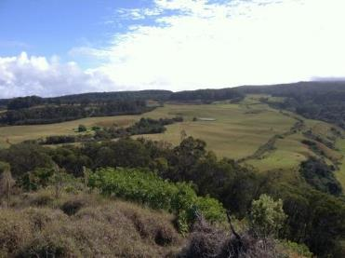
ITL Licensee: Piʻiholo Ranch, LLC.
Piʻiholo Ranch on Maui.

Project: Establish a Nēnē population on Piʻiholo Ranch.

ITL Duration: The ITL is valid for 50 years from September 21, 2004 to September 20, 2054; the SHA is currently expired. The original period was from September 21, 2004 to September 20, 2014.

Take Authorization: Incidental take of Nēnē on lands owned or otherwise controlled by Piʻiholo Ranch, LLC.

Baseline Condition: Following Nēnē reintroduction efforts on Maui that began at Haleakalā National Park in 1962, DOFAW began establishing a population in west Maui through a reintroduction program at Hana‘ula in 1995. However, prior to the development of the SHA, there had been no known Nēnē sightings at Piʻiholo Ranch premises by DOFAW staff or Ranch personnel. Therefore the baseline condition was determined to be zero. Under the SHA Piʻiholo Ranch was to maintain or improve approximately 600 acres of Nēnē habitat for a period of 10 years.

Status of ITL and SHA: Although the SHA is currently expired, the agreement is continuing as if it is still in effect. There was no take of Nēnē at Piʻiholo Ranch this fiscal year. The activities under the SHA were construction of a Nēnē release pen, predator control activities around Nēnē nesting and breeding sites, and out-planting native plant species known to be Nēnē food sources. There were 15 nests, including six re-nests, at the open-top release pen this past season, and two goslings successfully fledged the pen and were banded. Six goslings died before fledgling from inclement weather or unknown causes. No adult Nēnē died at the pen this year.

Nēnē monitoring recorded 27 banded birds on the Ranch throughout the reporting period, of which one was from the original released birds. The survey resulted in a population estimate for the Ranch of 31 birds. An island wide annual Nēnē survey was conducted on August 28, 2019. During this survey, no birds were observed. However, these birds only frequent the pen during certain times of the year and are also seen throughout the entire island of Maui.

The open-top pen’s fence line was continuously checked and maintained throughout the year. The fence and a broken water line was repaired, and a new electric fence unit was installed. The pond and automated waterers were cleaned and maintained weekly. Short grass habitat was maintained at the pen through weekly mowing and the area around the outside of the pen was maintained as needed. A total of 36.75 acres was mowed this year to maintain Nēnē short grass habitat and invasive fireweed was removed.

Predator control efforts from 70 traps resulted in a total of 53 mongooses, two rats, and seven mice trapped and removed around the open-top release pen at Piʻiholo Ranch.

Table 2 provides survey data for the original 48 birds released to the Ranch. The percentage of the original 48 birds that were re-sighted is a factor of survey effort and does not account for any unknown mortality or emigration from the Ranch, and may not necessarily be a measure of release success.

Table 2. Observations of Nēnē translocated to Pi‘iholo Ranch
Year | No. of Birds Translocated | Total Birds Translocated | No. of Known Fatalities | No. of Birds Sighted | Percentage (%) of Translocated Birds Sighted (excluding known fatalities)
2020 | 0 | 48 | 0 | 1 | 2
2019 | 0 | 48 | 0 | 3 | 6
2018 | 0 | 48 | 0 | 3 | 6
2017 | 0 | 48 | 0 | 4 | 9
2016 | 0 | 48 | 0 | 9 | 20
2015 | 0 | 48 | 0 | 10 | 23
2014 | 0 | 48 | 0 | 10 | 23
2013 | 0 | 48 | 0 | 11 | 25
2012 | 0 | 48 | 0 | 11 | 25
2011 | 0 | 48 | 1 | 16 | 36
2010 | 0 | 48 | 0 | 23 | 51
2009 | 0 | 48 | 1 | 26 | 58
2008 | 10 | 48 | 0 | 30 | 65
2007 | 25 | 38 | 2 | 26 | 72
2006 | 8 | 13 | 0 | 12 | 92
2005 | 5 | 5 | 0 | 5 | 100

Safe Harbor Agreement for the Reintroduction of Nēnē to Haleakalā Ranch, Maui.

ITL Licensee: Haleakalā Ranch Company.

Project: Establish a Nēnē population on Haleakalā Ranch, Maui.

ITL Duration: The ITL is valid for 50 years from May 22, 2012 to May 21, 2062; the SHA has been finalized as of August 2019.

Take Authorization: Incidental take of Nēnē on lands owned or otherwise controlled by Haleakalā Ranch.

Baseline Condition: There had been no Nēnē sightings at Haleakalā Ranch by DOFAW staff or ranch personnel prior to execution of the SHA other than those translocated, therefore the baseline condition was determined to be zero.

Status of ITL and SHA: No take of Nēnē at Haleakalā Ranch was reported this fiscal year. DOFAW in cooperation with Haleakalā Ranch has constructed a two-acre Nēnē release pen, conducts predator control activities around Nēnē nesting and breeding sites, and maintains access roads leading to the Nēnē release pen.

DOFAW conducted regular monitoring during the reporting period at Haleakalā Ranch. A total of 37 banded birds were recorded this season at the pen, of which 10 were from translocations. During the August 2019 survey, four Nēnē were observed. The population for the Ranch is estimated at 57 birds. However, these birds only frequent the pen during certain times of the year and are also seen throughout the entire island of Maui.

Nine nests were found in the open-top release pen this season and one nest outside the pen. Six nests were successful and ten fledglings were produced. Two goslings died before fledgling, and there were no deaths of adults.

Maintenance activities included checking and repairing fences and automatic waterers monthly. The water unit was checked and maintained monthly. The pond was drained and cleaned once a month and refilled with clean water, and the water catchment was repaired after damage from high winds. In total 34.75 acres were mowed in and around the pen to maintain short grass habitat and alien vegetation including lantana, guava, tomato, fireweed, and glycine, was removed. Due to erosion from storms, 500 feet of road leading to the pen was backfilled and repaired.

Predator control efforts from 41 traps resulted in a total of six mongooses and one mouse removed around the open-top release pen.

A total of 53 birds were translocated to Haleakalā Ranch between 2011 – 2016. Table 3 provides survey data for the original 53 translocated birds. The percentage of the original 53 birds that were re-sighted is a factor of survey effort and does not account for any unknown mortality or emigration from the Ranch, and may not necessarily be a measure of release success.

Table 3. Observations of Nēnē translocated to Haleakala Ranch
Year | No. of Birds Translocated | Total Birds Translocated | No. of Known Fatalities | No. of Birds Sighted | Percentage (%) of Translocated Birds Sighted (excluding known fatalities)
2020 | 0 | 53 | 0 | 10 | 19
2019 | 0 | 53 | 0 | 10 | 19
2018 | 0 | 53 | 0 | 13 | 25
2017 | 0 | 53 | 0 | 19 | 40
2016 | 8 | 53 | 0 | 28 | 60
2015 | 8 | 45 | 1 | 25 | 64
2014 | 0 | 37 | 2 | 23 | 84
2013 | 7 | 37 | 1 | 31 | 91
2012 | 20 | 30 | 2 | 30 | 100
2011 | 10 | 10 | 0 | 10 | 100

Safe Harbor Agreement for the Koloa Maoli or Hawaiian Duck (Anas wyvilliana) and the Nēnē or Hawaiian Goose (Branta sandvicensis) on ʻUmikoa Ranch, Hawaiʻi Island.

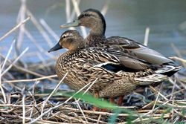
ITL Licensee: Umikoa Ranch.
Koloa Maoli or Hawaiian Duck, endemic to the Hawaiian Islands.

Project: Establish a Koloa and Nēnē population on privately owned lands of ʻUmikoa Ranch in the Hamakua District of Hawaiʻi Island.

ITL Duration: The ITL is valid from December 5, 2001 to December 4, 2100; the SHA period is from December 5, 2001 to December 4, 2021.

Take Authorization: Incidental take of Nēnē and Koloa, including their progeny, on lands owned or otherwise controlled by ʻUmikoa Ranch, provided that such take is above established baseline conditions.

Baseline Condition: The Baseline Conditions for Koloa and Nēnē were determined from monthly biological surveys conducted between January and October 2000. During this time there were five existing ponds ranging from 0.12 to 0.30 acres, providing approximately one acre of open water habitat, in addition to five acres of adjacent upland habitat. Surveys indicated that the ʻUmikoa wetland area was frequented by a single pair of wild Koloa. Therefore, the baseline for Koloa was determined to be two individuals, one acre of open water habitat, and five acres of adjacent upland habitat. The baseline for Nēnē was determined to be zero.

Status of ITL: No take of covered species was reported at ʻUmikoa Ranch this past fiscal year. The Ranch is responsible for maintaining fencing around ten ponds, consisting primarily of open water, and surrounding riparian and associated upland habitat totaling a minimum of 50 acres. Fences at two of the ponds were in need of repair based on a site visit in December 2018.

During state waterbird surveys in August 2019 (three ponds) and January 2020 (five ponds), no native or non-native waterbirds were observed.

Safe Harbor Agreement for Kamehameha Schools, Keauhou and Kīlauea Forest Lands, Hawaiʻi Island

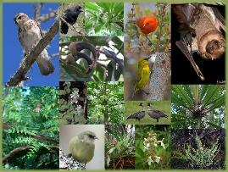
ITL Licensee: Trustees of the Estate of Bernice P. Bishop, DBA Kamehameha Schools.
Example species in the Kamehameha Schools SHA.

Project: Restoration and enhancement of habitat for native plants and animals.

ITL Duration: The ITL is valid from June 22, 2018 to June 21, 2068.

Take Authorization and Baseline Condition:

Table 4. Take Authorization for Kamehameha Schools SHA
Common Name | Scientific Name | Incidental Take Permitted  No. of Individuals or Habitat | Baseline Individuals or Habitat
Forest Birds:  ʻAkiapōlāʻau,  Hawaiʻi Creeper  Hawaiʻi ʻĀkepa  ʻIʻiwi | Hemignathus wilsoni  Loxops mana  Loxops coccineus  Vestiaria coccinea | Any habitat for the four forest birds above the baseline identified on the Enrolled Property | Approximately 4,162 acres of habitat in Forest Bird Stratum 1 on the Enrolled Property
Hawaiian Hawk, ʻIo | Buteo solitarius | Any habitat for the ʻIo above the baseline identified on the Enrolled Property | Approximately 18,517 acres of habitat on the Enrolled Property
Hawaiian Crow, ʻAlalā | Corvus hawaiiensis | Any individual on or at the Enrolled Property | Zero Individuals
Hawaiian Goose, Nēnē | Branta sandvicensis | Any individual on or at the Enrolled Property | Zero Individuals
Hawaiian Hoary Bat, ʻŌpeʻapeʻa | Lasiurus cinereus semotus | Any habitat for the ʻŌpeʻapeʻa above the baseline identified on the Enrolled Property | Approximately 18,517 acres of habitat on the Enrolled Property
None | Asplenium peruvianum var. insulare | Any individual on or at the Enrolled Property | 128 Individuals
ʻŌhā wai | Clermontia lindseyana | Any individual above the baseline on the Enrolled Property | 24 Individuals
Hāhā | Cyanea shipmanii | Any individual above the baseline on the Enrolled Property | 463 Individuals
Hāhā | Cyanea stictophylla | Any individual above the baseline on the Enrolled Property | 104 Individuals
Kīponapona | Phyllostegia racemosa | Any individual above the baseline on the Enrolled Property | 4 Individuals
None | Phyllostegia velutina | Any individual above the baseline on the Enrolled Property | 38 Individuals
None | Plantago hawaiensis | Any individual above the baseline on the Enrolled Property | 1 Individual
None | Vicia menziesii | Any individual above the baseline on the Enrolled Property | 27 Individuals
ʻĀhinahina | Argyroxiphium kauens | Any individual above the baseline on the Enrolled Property | Zero Individuals
ʻŌha | Clermontia peleana | Any individual above the baseline on the Enrolled Property | Zero Individuals
ʻAkū | Cyanea tritomantha | Any individual above the baseline on the Enrolled Property | Zero Individuals
Haʻiwale | Cyrtandra giffardii | Any individual above the baseline on the Enrolled Property | Zero Individuals
Haʻiwale | Cyrtandra tintinnabula | Any individual above the baseline on the Enrolled Property | Zero Individuals
Hau kuahiwi | Hibiscadelphus giffardianus | Any individual above the baseline on the Enrolled Property | Zero Individuals
ʻOhe | Joinvillea ascendens | Any individual above the baseline on the Enrolled Property | Zero Individuals
Alani | Melicope zahlbruckneri | Any individual above the baseline on the Enrolled Property | Zero Individuals
None | Neraudia ovata | Any individual above the baseline on the Enrolled Property | Zero Individuals
ʻAiea | Nothocestrum breviflorum | Any individual above the baseline on the Enrolled Property | Zero Individuals
None | Phyllostegia floribunda | Any individual above the baseline on the Enrolled Property | Zero Individuals
None | Phyllostegia parviflora | Any individual above the baseline on the Enrolled Property | Zero Individuals
Makou | Ranunculus hawaiiensis | Any individual above the baseline on the Enrolled Property | Zero Individuals
ʻĀnunu | Sicyos alba | Any individual above the baseline on the Enrolled Property | Zero Individuals
ʻĀnunu | Sicyos macrophyllus | Any individual above the baseline on the Enrolled Property | Zero Individuals
None | Silene hawaiiensis | Any individual above the baseline on the Enrolled Property | Zero Individuals
None | Stenogyne angustifolia | Any individual above the baseline on the Enrolled Property | Zero Individuals

Status of ITL: Due to the COVID-19 modified operating conditions, some work scheduled for FY 2020 was deferred. In FY20, a total of 10,207 native plants of 16 species were planted. Of these 9,057 were koa seedlings. In the reporting period all of the outplanting occurred outside of Forest Bird Stratum 1. Planting areas were concentrated in the lower portions of the Enrolled Property and outplanting was conducted by collaborators and vendors prior to the onset of
COVID-19 related social distancing in March 2020. Silviculture activities included 62 acres of new koa located in the 2018 wildfire burn area in the southwestern portion of the property, as well as thinning, singling, and pruning improvements throughout existing koa stands.

In FY 2020, all fence lines were regularly inspected, and repaired as needed, to maintain ungulate exclusion. 2,000 meters of fence were replaced in the reporting period. No signs of ungulates were observed for the fifth consecutive year in upper Keauhou. Pig signs were observed in the lower Keauhou and Pu‘u Kipu units and control work is ongoing. Two pigs were removed in FY 2020.

The wildfire in August 2018 consumed 3,739 acres including 649 acres of the enrolled property in addition to the much larger area in the adjacent Volcanoes National Park. In response to the 2018 wildfire, an 18,000 foot firebreak was installed along the property boundary with National Park in FY 2019. In FY 2020, Kamehameha Schools inspected and maintained all water sources, access routes, the new firebreak, and tertiary roadways.

Weed surveys by Kamehameha Schools and Three Mountain Alliance (TMA) were conducted on 5,151 acres and suppression occurred across 2,541 acres and targeted priority weed species Faya (Morella faya), Ginger (Hedychium gardnerianum), Strawberry Guava (Psidium cattleianum), and Himalayan Raspberry (Rubus ellipticus), as well as Blackberry (Rubus argutus). Existing populations of priority weed species was below 10% within conservation fences that is a criterion specified in the SHA. Kamehameha Schools provided access of the enrolled lands to the U.S. Forest Service for researchers monitoring the presence, patterns, and impacts of Rapid Ōhiʻa Death (ROD).

Monitoring in FY 2020 included a bird survey for the covered species. Results are as follows:

ʻAlalā from the 2017 and 2018 release cohorts continued to frequent Kamehameha Schools lands with activity being focused around the Puʻu Kipu area, and in early 2020 a pair of ‘Alalā demonstrated behavior that could have indicated the establishment of breeding territory, but this did not come to fruition.

Up to 14 Nēnē were observed during monthly surveys in the western portion of the enrolled property and up to nine at the ʻŌhiʻa Ranch portion. One active nest containing four eggs was observed at Keauhou and two of the eggs are believed to have hatched; however, neither the nesting pair nor their goslings were seen. In addition, one gosling Nēnē was observed on a remote camera trap near the Keauhou Nēnē Cabin in December 2019. The single gosling appears to have been raised to fledgling size and likely fledged successfully with its parents.

Plant monitoring of covered species was conducted in FY 2020 through a contract with the Hawai‘i Plant Extinction Prevention Program (PEPP). Six of eight covered plant species show declining population numbers, due to poor survival of outplants and possible lifespan considerations. Cyanea shipmanii and Cyanea stictophylla maintained all of the original population units and experienced a net increase in the number of population units. It appears Phyllostegia racemosa and Plantago hawaiensis are currently extirpated from the property. Vicia menziesii experienced a drastic reduction in the number of both individuals and population units. Through the discovery of new locations Asplenium peruvianum var. insulare and Clermontia lindseyana maintained the same number of populations units. Natural regeneration was observed only for Vicia menziesii and Cyanea shipmanii at Puʻu Kipu. In Spring 2020, Kamehameha Schools contracted Kilioe LLC to further survey the Area Requiring Additional Conservation Commitments for new locations of endangered plant species. To date, the survey has resulted in the location of two new populations of Asplenium peruvianum var. insulare totaling at least 34 individuals, three new Clermontia lindseyana individuals, and one new population of Vicia menziesii with 13 individuals. The survey is ongoing and final results are expected in FY 2021. Kamehameha Schools is also working with DOFAW to develop a collaborative recovery program for Vicia menziesii, which is currently known only from the property.

